

**Final Report**

**Of the**

**Financial Crisis Inquiry Commission**

*Section IV: The Economic Crisis*

Draft #1

July 20, 2010

Contents

1. Introduction 10

A. The economy on the eve of the crisis 18

B. Late 2007 through mid-2008: Some housing trouble, liquidity crisis and mild recession 24

C. September 2008: Financial crisis hits hard 29

2. U.S. Economic Pain: The link between the financial system and specific sectors 30

A. Business lending dries up 31

Large business lending 31

Small business lending 40

B. Unemployment 48

C. Impacts on households 54

Impacts on wealth 56

Mortgage-market shock 58

Credit Cards 62

Consumer confidence 63

Impacts on consumer spending 64

Retirement Accounts and Pension Funds 72

D. Impacts on government spending 73

State and local government finances 74

Federal Fiscal Crisis 79

The Financial Sector 80

E. Global impacts 83

**General Comments from Commissioners**

***Bryon:*** *Likes the publisher pitch more than Section IV. Housing not core cause – there are many causes.*

***Phil:*** *Start with the consequences and state of affairs. Here’s where we are and how did we get here.*

***DHE: stayon the facts – difficult because of genera target.***

***PW:***  *generalization of data.*

*PA: all – chronology important.*

PA: he is concerned about the organs, not fingers and toes – how do we join those issues. Identify 5-6 kahunas that separate us – concurrently, we need to give to the staff the WHO and WHAT.

**Phil Angelides**

Commercial real estate needs to be focused on more.

Financial Crisis becomes Economic Crisis. State of the economy as it evolves parallel to the financial crisis.

Being careful about being non-predicative of the future.

Need to spend more time at the ground level – more on origination/mortgage brokers/fraud/foreclosures.

Need to be surgical on how we deal with international/global crisis.

(JWT – early on in our commentary – capital inflows discussion demonstrates international effect; weave it in but not central, ripple effect on how. (JWT – interesting graph – Chinese exports to the United States)

(BB; compact discussion on why the whole world had an economic/financial crisis – maybe we could try again – maybe an ppendix? Global implications of our crisis is important.)

(DHE: 3 places that global crisis pops up- international response, bubbles overseas, and aftermath. Segment on global or intersperse it? PA says intersperse it.

(Wendy – what about Bob? Differences in entities that didn’t suffer)

(Byron: study Canadian economy – similar to us)

(PA – in addition to Doug is international regulatory framework)

(Keith – agrees with Doug)(bubbles overseas - test) (transmission across boarders) (if we discuss policies – international coordination is of high importance)

(PA regulatory framework)

WE – in this section – filter it down through global trade?

1. As the staff indicated in its transmittal, this section - and the report as a whole - needs to be in more of a narrative form. It needs to be written for the broader public, not just a narrow band of policymakers and financial experts.
2. The language needs to be tightened up and more precise. A strong narrative and precise verbiage are not mutually exclusive, particularly given the inherent power of the subject about which we are writing.
3. Statements need to be substantiated. Specifically, they need to be coupled with appropriate facts, data, or vivid and real examples of what we are describing.
4. While our original research and investigative work has focused mostly on the financial crisis, we need to more fully utilize the information we have acquired through our interviews, research, and investigation.
5. We need to couple broader concepts with specific examples about communities, businesses, and families to make our work as relevant as possible and to best explain how and why the financial crisis became an economic crisis and came to dramatically affect the daily lives of tens of millions of Americans.
6. There is repetition in the current draft that needs to be eliminated. There are also some inconsistencies that must be cleared up.
7. Since we will cover the financial crisis in other sections, we should repeat the facts/causes of that crisis only as needed to give context to our effort to explain the causes of the economic crisis.
8. We need to be careful re use of present tense. While the crisis is ongoing, when we publish our book, everything about which we have written will then be in the past.

**Brooksley Born**

*If this section is going to go at the end – don’t be repetitive.*

*Transmission and business’ ability to borrow.*

*Interventions*

*JWT – big banks shift in revenues and volatility – explain what is propping up banks and revenue at this time*

*BG: competition among traders lessened because few competitors*

*KH: staff produce a single piece of paper with two columns – our reader understands this and our reader doesn’t understand…what is target reader’s background*

*Intervention*

*Byron: need to identify actions taken by the government. Don’t necessarily need to pass judgment. Heather – more important, not what it was called, but where the money came from and what it was meant to do. Keith: heavily into this subject area – let’s list and describe the actions that were taken. (Did Greenspan at the Fed help cause the credit bubble). PA comes back to action or inaction triggered, accelerated, etc – fair for our purview.*

*PA/HM – bring TARP facts before us – factual – let’s discuss.*

Our statutory mandate is to explain the causes of the economic crisis, and we should try to focus the Section on that. The purposes of this Section should be to describe the on-going economic crisis and to describe its causes, showing how the financial crisis impacted on the real economy and then how the real economy went into a downward spiral. Basically, we should show how the credit crunch and the fall in asset values impacted production, reduced business and household spending, caused unemployment and business failures, etc. There should be a greater emphasis of these impacts.

In terms of tone, I agree that we need to craft this into a narrative. In some places, we make generalizations that need to be described in more detail and supported. In other places, we give a great deal of detail that seems to be a distraction from the flow of the narrative and perhaps of more interest to economists than to the general public. I also agree that we need to provide illustrations or case studies that make the narrative more vivid.

[It is difficult for me to comment on the substance of the draft because the commissioners have not really been provided with much information on the economic crisis as opposed to the financial crisis.

[It might be useful to write the introduction after the rest of the section is fully fleshed out and to use the introduction as a narrative summary of the section as a whole. The introduction currently seems to include restating a description of the financial crisis , which will have been described in much greater detail in the earlier sections.]

**Douglas Holtz-Eakin**

1. There is a difference between a narrative tone and sloppy, loose language.  I have no idea what “stunning” means in an empirical context, nor “shambles” nor “devastated wages”.  The draft is riddled with judgment and coloration that I cannot support.

1. The scope is too wide.  There is no reason this Commission should be opining about the impact of the ARRA on consumer spending, for example.  The CARS program was originally an environmental initiative that got relabeled for political purposes.  We should steer clear (pun intended).

(PA) – agrees scope is too wide and shouldn’t be opining. But CARS program – no matter what

political birth – if government intervention, it should be mentioned.

1. There is a lot of repetition of points.
2. The economics are tenuous. What does “downward spiral” (used repeatedly) mean exactly?  It send the impression that there is no equilibrating mechanism and that economies only spiral down (or spiral up?).
3. Why are we citing political sources like *Economic Report of the President*?

(PA) – what is the issue? (DHE) – it is a political document. (PA_ =ok to not cite FACTS from this document.

**Peter Wallison**

What happened before the crisis. Why the crisis occurred.

If this chapter has a role in our report, it should be the first chapter rather than the last. As the first chapter, it should record what happened in the economy that could be reasonably identified as a cause the financial crisis. Our charter is to identify the causes of the financial crisis. This chapter is focused on the results. If left as it is, when the report comes out people will justifiably wonder why we have spent so much time and money to tell them what they already know. As I’ve said before, we are in danger of writing a report about the financial crisis—like dozens of other books--rather than a report about the *causes* of the financial crisis.

*Will write something. Far from agreement with everyone else. Wrong audience; should be for policy makers.*

**Bill Thomas**

1. This needs more descriptive, narrative content (i.e., concrete examples of the impact of the crisis on non-financial markets and firms) in order to place the discussions of specific economic indicators and dynamics in credit markets in context, and take the place of vague adjectives.  Additionally, the language needs to be made more accessible, including further description of what each indicator we use means and what its significance is for the discussion.

2. Unless (1) it is necessary to understanding the motivation for a policy action or (2) there is something unique about the statement, I think that we should avoid citing specific papers or economists’ projections in the text.  There are always a hundred voices in any debate, and we don't need to be highlighting any specific expert's opinion on what the future will look like.  In the same vein, we should stay away from offering our own economic predictions, because they are by their nature uncertain, and don’t seem relevant to the task at hand.

(PA) not our paper/investigation. Unique or relevant to the story.

3. We need a discussion of differential impact across the country and highlight specific regions that have been hit harder than others, and why.

**Heather Murren**

Comments have been made. PA – you were an advocate of citing specific stories and stories of individuals.

**Keith Hennessey**

**2. Without the financial crisis , we would have had a soft landing. Disagrees with notion that a big recession was building up and came on in ’08. (#16)**

**#. What ever structure we sue – we have a timeline.**

**(Insert timeline production into report production schedule)**

**Comprehensible vs. completely accurate – how to solve our language issue. Story vs. academic report.**

**Economic Proposition that financial crisis led to weakness in economy and that led to further bank failures. CRE/foreclsoures forthcoming, etc.**

**The affect of the crisis on state finances and pension funds. Not CA. Don’t attribute affects of the crisis to other bad decisions/circumstances.**

1. I continue to struggle with the top-level outline.  Section I is “meant to establish the tableau for the financial crisis,” and “will examine America’s financial and economic conditions in the decades leading up to the early 2000s.”  The outline made me think that Section IV would be about the back-end:  what happened to the economy as a result of the financial crisis, especially the market crash, the collapse of several large financial institutions, the freeze of interbank lending and the seizure of several securities markets, and the severe decline in business, investor, and consumer confidence and spending beginning in August/September of 2008.  Instead, Section IV tries to cover 2006 through 2009, but only in some respects.  I cannot understand how time will flow for the reader, either by reading the outline for the whole report or by reading section IV. **Recommendation:  I think we need to have a structural discussion about how a chronology interacts with the four chapters.**
2. Related to (1), I have a tough time understanding the purpose of part one of Section IV.  It is trying to describe a chronology up to and including September of 2008, but isn’t that what Sections I through III are supposed to do?  I think this relates to my confusion about the top-level outline.  If we’re going to do macro background and try to describe “the economy on the eve of the crisis,” then shouldn’t that be much earlier in the report than Section IV?  
   **Recommendation:  If Section IV is about the effects of the crisis, then it should exclude part one (intro through September 2008).**
3. Part two of the Table of Contents of Section IV has some structure to it, but while reading through the chapter it felt like I was reading a series of unconnected data analyses.    
   **Recommendation:  In particular, work on 2(c) so it’s more connected internally.  It reads like a laundry list.**
4. In part two of Section IV, I suggest moving A (business) after C (impacts on households).  That way the sequence goes:  (un)employment, impacts on households, impacts on businesses, impacts on governments, global impacts.  I think that is an important prioritization signal.  Also, the impacts on businesses were broader than just the lending freeze, no?

**Recommendations:  (1) Order part 2 of Section IV:  Unemployment, Impacts on Households, Impacts on Businesses, Impacts on Governments.  (2) Rename “Business lending dries up” as “Impacts on Businesses” and expand it to include more than just the effects on business lending.  (3) Similarly, rename “Impacts on government spending” to be “impacts on government finances” and include effects on government revenues.**

1. **Recommendation:  Within subpart D of Section IV, I suggest putting federal fiscal crisis ahead of state and local government finances.**
2. I share Doug’s view on some of the tonal language.  I strongly recommend we have a high-level narrative structure to the report, but that does not mean we need to take a narrative tone or use emotionally charged language.  I think we should present facts and judgments where we can, but for the Commission to express emotions doesn’t feel right.  There’s a big difference between the tone one or two authors might take, and the tone that a group product must/should take.  
   **Recommendation:  Remove imprecise and emotionally charged words such as those indicated by Doug.**
3. We need a structural decision from the Commission about whether we are going to report on the actions taken by the federal government (and international governments?) to address the crisis.  Last fall I recommended we discuss not just the causes of the crisis and the effects of it, but that we also evaluate the TARP, TALF, FDIC guarantees, stress tests, international policy coordination, etcetera.  Others disagreed with this view – the two I remember most strongly advocating only focusing on the causes of the crisis were Phil and Peter.  As I said last fall, it is difficult to discuss the effects of the crisis without discussing the intermediate step between the causes and the effects – the government actions.  I don’t see how, for instance, we discuss the effects of the crisis on small business without covering the unlimited FDIC guarantee of deposits, which it was argued at the time was necessary to prevent small businesses from withdrawing their payroll accounts from small and medium-sized banks.  It may even be impossible to discuss the failures and near-failures of certain large financial institutions without discussing the role government did (and sometimes did not play) in those failures.  This draft occasionally touches down on policy actions, mentioning TALF, auto loans from TARP, Cash for Clunkers, the AIG bailout (from TARP), and international policy coordination.  Either we’re going to discuss the policy actions taken or we’re not.  Glancing briefly at them doesn’t work – how can we mention the auto loans from TARP without discussing the Capital Purchase Program?  I maintain my original view – I think the report should analyze the policy actions taken.  I understand that others felt differently, but if we’re not going to then somebody has to figure out how to talk about the effects of the crisis without talking about the intervening policy steps.  I don’t know how to do that.  Mentioning policy actions, sometimes related to their secondary or tertiary effects, without discussing the actions themselves or their primary effects, reads oddly in this draft.  
   **Recommendation:  If the report is not going to cover the policy actions, then they should be excluded from this section.  I would prefer analyzing the policy actions, but the Commission has not been headed this way since the Chairman pushed hard to focus only on the causes of the crisis late in 09 and earlier this year.  We should either review this structural question at the commissioner level or strike the policy references within this section.**
4. Quoting non-governmental commentators – Any time the report quotes someone who participates in the debate on public policy and is not a government official or a participant in the crisis we run the risk of sending signals that we endorse other views expressed by that person.  Thus, I’m good with citing Greenspan or Bernanke or Geithner or any government official (Bush Administration, Obama Administration, Congress, or a federal regulator, for instance), but citing Dr. Krugman and Dr. Zandi as if they are objective economic analysts is heavily laden with political signaling.  I assume this is unintentional in draft #1.  But I can think of few more provocative ways to begin a chapter like this than to quote Dr. Krugman in the opening section.  Imagine, for instance, the reaction from some on the left if the report were to quote Wall Street Journal editorial page writings.  
   **Recommendation:  Steer clear of quoting non-governmental non-participant commenters unless absolutely necessary, especially when those commenters are heavy participants in the public policy debate.  If we are going to cite someone like this (e.g. Rogoff/Reinhardt), make sure that the point being made is absolutely necessary for the report, and if it is a hotly disputed point, label it as the view of a particular party rather than as objective truth.**
5. The chapter begins in 2006.  Why?  What evidence do we have that “the housing crisis began in 2006?”  
   **Recommendation:  We need an explanation of why the staff believes 2006 is the appropriate starting point for any economic historic description, why they think the “housing crisis began in 2006,” and then a discussion about whether this is the right starting point for a narrative.**
6. The chapter suggests that the growth in home price values, mortgage equity withdrawals, and financial assets was “mostly” responsible for the strong economic growth from in the mid-2000’s.  This is a hypothesis that I understand is subject to considerable debate.  Please back up the claim and provide us with the best arguments on both sides of that debate.  Large imbalances were clearly accumulating, and the sharp and painful resolution of those imbalances caused severe economic pain.  But it’s a separate argument that the forces that created those imbalances were also the causes of the bright economic picture pre-2008.  If we’re going to make it we need to understand it and prove it.  
   **Recommendation:  Staff needs to provide supporting evidence for this claim.  Please explain why it is relevant to understanding the causes of the financial and economic crisis.**
7. We need to be extremely careful about both hindsight bias and selection bias.  Things that are now obvious in retrospect may not have been so at the time.  This draft makes a case that the housing problems began in 2006, and that because there were people pointing this out, it was obvious at the time.

Example:  “At the end of 2006, some economists thought that the American economy was due for a recession, driven by the slowdown that had already begun in the housing market.”  (p. 7) – A FRBSF Economic Letter by two Fed staff economists is cited.  This suggests that at the end of 2006 there was a high-level debate about the future of the U.S. economy, and that policymakers made decisions in part based on their views of who was right in this debate.  That does not square with my recollection.  As I remember it, in 2007 there was a general high-level consensus among most major government and private sector forecasters that the U.S. economy was healthy.  By the end of 2007 there were some who were correctly forecasting a slowdown and even a recession.  And very few were correct in predicting the shocks and collapses that happened in 2008.

**Recommendation:  Strike this sentence and the reference to the FRBSF letter.  If there is evidence of a broad economic debate on this question in late 2006 (rather than just a couple of random Fed staff economists), staff should present it.**

**Byron Georgiou**

Agrees with keith’s points on pensions.

I think this section probably needs to lead the report, not conclude it, except for the portions detailing the recovery of certain institutions, like the financial sector, which should probably conclude the report and be broadened into a chapter on the current (as of 12/15) state of the economy including the sectors that have recovered, those that have not, and the residual consequences of the crisis that imperil the economy in the future, shoes that have not yet dropped or continuing, in some cases accelerating impacts of shoes that have already dropped.

I believe that the intro section should include, as I have noted in my edited draft, a serious explanation of the retirement crisis exacerbated by the financial crisis.  Not only are almost all entities relied upon for future retirement benefits to existing and future retirees seriously underfunded, this underfunding in an environment where plan sponsors, governmental and private are hurting from the economic crisis means that the sponsors are unlikely to allocate scarce resources to the further capitalization of retirement funds and more likely will be forced to scale back already inadequate funding commitments, thereby leading to reduced benefits for existing and future retirees. which will lead to less spending by retirees, and more demands for safety net services for retirees, which will not be able to be met by federal, state and local governments suffering from the decline in revenues resulting from the financial crisis.  This is a big problem, highlighted in many articles, including a front page story in the NYT on a Sunday some two or three months ago, which I suggest someone review.

The middle of the report should address the various causes we have identified, and the conclusion of the report should provide an assessment of the future which I believe to be quite grim, which of course is why the Congress required us to report after, not before the midterm election.

This leads me to differ with Phil 's point 8 on the use of the present and past tenses.  Regrettably, I believe when we issue the report, the financial and economic crisis will still be very much with us, fully in the present.  I  belive it is our duty to identify those areas that have recovered and to what extent they have recovered, and those that have not recovered or recovered only slightly and the continuing future effects on the real economy from the financial and economic crisis that hit us so hard two years ago.  While portions of the financial services industry may have recovered, either somewhat or to a significant extent, most of those recovery earnings are finding their way to executive compensation and shareowner dividends and share price recovery, and not to the financing of growth in the real economy businesses that, if funded, could lead us out of this quagmire.  I believe we need to evaluate this so that our report remains relevant as a call to continuing efforts to address the consequences of the crisis.

[This introduction will create a narrative of the downward spiral [KH: I share Doug’s concern about the phrase “downward spiral” in several places.  If we’re going to use that phrase or concept, I need to understand what it means and why we think it’s the case. **Recommendation:  Strike or justify the “downward spiral” language.  If the concept is to be used in the report, staff should give a precise description of what that term means.**] in the economy that was created first by the financial crisis and then the worsening economic crisis. The introduction will also include a graphic on how PA the credit crunch PA led to a decline in business activity, which PA led to layoffs; layoffs PA led to lower wages [PA these changes made to indicate that this section should be specific to this crisis, not generic]; lower wages and lower wealth from asset price declines lead to lower household spending; they also lead to mortgage foreclosures; lower spending hurts businesses, leading to business failures, which leads to businesses defaulting on debt; foreclosures and business defaults hurts the financial system; the financial system intensifies the credit crunch, etc…] DHE **[What about stabilizers and equilibrating mechanisms?]**HM: I agree that the language we use should be precise, as opposed to hyperbolic, when we describe the factual aspects of the crisis so to not undermine the analytical nature of our work. The facts also are powerful and self-evident and don’t need embellishment. But in addition, we need to effectively capture the dramatic aspects of the crisis and create an effective and engaging narrative as part of our objective to reach all people, not just finance folks. We can do that in a similar way to the 9-11 report - use people. For example (I am making this up). John Doe of Bakersfield California awoke on a sunny morning in the month of xxx to go to work at his construction company and arrived to find the doors locked and a legal notice. Back in NY, Jane Smith was enjoying a longer than usual lunch at Smith and Wollensky – bonuses had been given out for the CDO desk that day and she was going to make the down payment on her house in the Hamptons. You get my drift. Then you can then back it up to describe how we got to a place where Joe’s company closed and Jane’s company was coining money and perhaps follow them through the foreclosure process or corporate governance, but it is easier to care about individuals as opposed to concepts. PA: The purpose of this section is to lay out the causes of the economic crisis that affected tens of millions of Americans. It should cover why and how the financial crisis morphed into an economic crisis.It should help the reader understand in a logical, narrative fashion how the various events and forces cascaded/came together/ reinforced each other,etc to produce a crisis of such magnitude. It should also examine the extent to which underlying weaknesses in the economy itself –combined with the financial crisis – helped push the country in a deep recession. The introductory section should give a sense of the overall picture so that there is context for what follows. It should leave readers with a clear understanding of what has happened to our economy, communities, and households and why.]

According to conventional wisdom before the crisis HM: what time period exactly? , banks and debt markets would back each other up in crises, making sure businesses and households never went for long without a source of credit.[1] BB [There is no footnote 1. I am unfamiliar with this conventional wisdom. Is it generally a view of economists or of non-economists as well? Unless the public in general believed that the debt markets were an adequate and sufficient layer of protection in a credit crunch, I think we are making too much of this point.]DHE **[No footnote]**  Federal Reserve Board Chairman Greenspan, in a 1999 speech, argued that Asian economies and markets crashed in the 1990s because they relied too heavily on banks for financing, while American capital markets furnished a “spare tire.”PA In fact, the economy had weathered the 1987 stock market crash, the failure [PA didn’t fail] of Long-Term Capital Management in 1998 BB [LTCM didn’t fail since the Fed facilitated a bail-out by the derivatives counterparties so this was not a real test of the system] and the bursting of the Internet bubble in 2000 BG: and the collapse of WorldCom and Enron.. PA And, since the end of the S&L crisis, the U.S. has had very few bank failures and only brief and shallow recessions. BB [Does this paint too rosy a picture of the economy from the early 1980s to the mid 2000s? I remember a lot of turmoil and efforts by the financial regulators during the late 1990s.] .[PA Do we mean here to talk re seeming stability of the financial system, rather than the economy as a whole ?]

But the conventional wisdom was wrong.

Both BB lending by traditional commercial banks and wider credit markets BB virtually stopped functioning [PA more precise language – as an example] HM: do we want to describe what their function is? The reason I ask is that we will need to start setting a general threshold for the whole report for what audience we want to reach – most people have only a bare understanding of what credit actual is and what it serves to accomplish in the fall of 2008, with consequences that continue to reverberate PA throughoutthe economy. BB Many consumers and business people, uncertain or fearful, put off borrowing, while BB some of those who PA attempted to do so found bankers unwilling to lend and debt markets PA shuttered. For the first time since the unregulated debt markets emerged in the 1990s BB [I think that both the commercial paper market and the repo market existed pre-1990, though they may have grown significantly after that],DHE **[What exactly does this mean?]**  this crisis shocked BG into paralysis both these markets and conventional banks BG . BB [This paragraph may overstate the situation; banks may not have been lending as much as they had previously, but they did not all completely abandon lending, and they were certainly functioning in other ways--for example, taking deposits.]

The cataclysms in the financial markets in 2007 and 2008 – the collapse of the housing market; the sudden, stunning fall of storied companies like Lehman, Bear Stearns, and AIG; and the drying up of credit – were severe enough and happened so close together DHE **[There is a HUGE difference between the failure of individual firms and “drying up of credit”. I doubt the former could produce the apocalypse you are asserting; the latter is very different.]** that they helped turn what might have been an ordinary recession into the worst economic crisis PA/BG since the Great Depression. BB [In what respects is the current crisis not as significant as the recession in 1982? Why are we unwilling to say, as so many authorities have, that this is the worst crisis since the Depression?]since the Great Depression. BB [This sentence seems to suggest that the causes of the economic crisis may have included factors other than the financial crisis. If so, what were they? Are we trying to establish that the country would have gone into a recession even without the financial crisis and if so why? What evidence supports that notion?]

[Downward spiral. The economy was poised for recession; DHE **[this is 20-20 hindsight and hardly inarguable]**; HM: how so? [PA need facts – as an example of areas where we will need to make sure that statements are coupled with facts, recognizing that this was put in brackets by the staff] the crisis made it much worse; HM: you must then be picking a time period to define the crisis, what is that time period? ; there was a downward spiral—crisis affected borrowing, which led to less investment, which led to more layoffs, etc.]

As financial markets froze and asset prices collapsed, the biggest parts of the economy – business investment, consumption and state and local government spending – all plummeted. BB [I wonder if we need to make more of a point about the fall of asset prices including for example the collapse of the securities bubble which devastated investments.] Unemployment spiked. .[PA Cover other major impacts such as foreclosures due to rising unemployment,etc] While the economy partly recovered in 2009 – PA with financial institutions bouncing back and many [some?] industries which could now PA be able to borrow again – unemployment remains high at the time of this writing and the outlook is unclear. .[PA Need to watch use of present tense given a certain publishing date and should stay away from prospective statements] [Insert more about the current economy, numbers of employed, numbers of discouraged workers, loss of output, regions affected by foreclosures, etc.]. DHE **Why are we devoting space to a current economic outlook that will be obsolete and is beyond our mandate?**]; WMT: GDP figured needs context.

HM: Also quotes from regular people, not just ‘experts’.

US GDP quarterly changes: 1970-present BB [Why do we have the chart here even though we are not discussing the effect of the financial crisis on production? I think that it is important to include a discussion of the impact on production.] [PA this chart is unexplained and seems unrelated to proximate text]

The housing crisis DHE **[this is a vague concept – is it the values? Mortgages? Subprimes?]**HM: do you mean downturn in demand and price weakness that began in HM: what month did it start to roll over? 2006 HM: what made it a crisis? The severity of the decline in prices? and the ensuing financial crisis [PA or “the financial crisis that ensued] [WMT: Is this referring to the collapse of the BSAM funds/drying up of CP in 2007? I think “spilled into the broader economy a year later” is confusing me.] spilled into the broader economy a year later, first as a drop in real estate prices that devastated household BG and business wealth, next as a credit crunch that helped to shut factory production lines, put people out of work, and ultimately redounded onto the banks in the form of foreclosures and bankruptcies. As real estate sales dropped and values plunged BB and credit froze, households and businesses PA pulled back on [again, as an example of precise language] spending and investing. BB [Again, you might want to add that the crash of the stock market also impacted savings, spending, lending, etc. We should discuss the impact on businesses (as well as households) of losses on investments and other assetsDHE **[Values dropped in 2007 and this did not happen.]**

Concerns about the markets and the economy, reflected in business and consumer confidence surveys, made consumers and executives even more reluctant to spend or invest, creating a downward spiral DHE **[meaning what?]** that slowed the economy further.[2] [Cite these surveys.] HM: quote people too

Investors [PA investors?] and banks were much less willing DHE **[less willing than what?]**  to lend because they doubted the creditworthiness of borrowers or did not have cash to lend. Many debt markets almost completely shut down for consumers and small businesses. And then, as their own sources of funding dried up, banks had trouble lending, even if they wanted to. While BG some large businesses [PA more than large businesses had lines] could draw on the lines of credit that they had with their commercial banks, banks made few new commitments. HM: (this is made up) At the First Bank of Miami, the chief credit officer is under major pressure from regulators who had awakened from a long slumber and are suddenly going through all the files to review asset quality. He had to tell his best friend from grade school that they could not roll over his LOC for his small business loan. This lifetime fisherman had to file for bankruptcy, laying off 60 people.

DHE **[this para is very repetitive]** The resulting sharp decline in economic activity created a downward spiral DHE **[Ugh]** that led to higher unemployment. HM: Maybe we should track how many people are out of work and weave it through the whole report– starting in 2006. So at each point in our narrative we say “and now there are xxxxx people out of work in the United States” ? as a way of benchmarking the impact in a visceral but factual way. Same with foreclosures. [Include a case study of a business that couldn’t get financing and had to lay people off, making BG several high-foreclosure BG , all over America for example, even worse]. As workers are laid off, they BG were not be able to pay their mortgage or credit card debt. BG When they defaulted, the bank suffered losses and in turn had to curtail lending. .[ PA The two preceding sentences should be put in real terms re this crisis]This close link between the financial markets and the day-to-day lives of people – the link betweenPA Wall Street and Main Street – was one primary reason that the crisis has been so severe. DHE **[This makes no sense. The financial and real sectors have ALWAYS been linked so it can’t be the reason that the crisis was so severe.]** [PA We need to lay out why this economic crisis was particularly severe.] [BB: We need to make it clear that this link is not a new phenomenon but rather is the reason that financial crises impact on the real economy.]

These big problems, and the potential for more, spurred Federal Reserve and Treasury officials to PA undertakeunprecedented market interventions throughout 2007 and 2008. When the Federal Reserve opened the discount window to a broader range of companies in August 2007, Chairman Ben Bernanke said, [“”]. Justifying the $[XXX] billion support to money market funds in 2008, he said, [“”]. Timothy Geithner, president of the Federal Reserve Bank of New York, said that [“”] would have happened if the government had not provided financing to the giant insurance company AIG. [Add quotes from Paulson and Geithner at our interview or testimony]

## The economy on the eve of the crisis

At the end of 2006, some economists thought that the American economy was due for a recession, driven by the slowdown that had already begun in the housing market.**[3]** [WMT: The FRBSF paper talks mostly about the inverted yield curve’s predictive capacity, not about the role of the housing market in the recession.]For years, housing construction had played an unusually large role in economic growth , and these economists thought that was BG certain to end. [WMT: I think that the primary question here is not “did we think that we were due for a recession in 2006” but rather “were we due for a recession in 2006?” The point here is that, given the increased role of construction in the economy during the mid-2000s, the leveling of the housing market may have generated a recession – but not necessarily a crisis. I am concerned with citing any single report or economist with the implication that they had “got it right.” Better to invert these paragraphs – talk about the weaknesses in the economy that existed and then say that some economists recognized this fact in real time. It’s also not clear that we were poised for a recession, given how frequently recession-predictions end up being false. That is a different statement than identifying potential fault-lines.] [PA Was it just the slowdown in housing or were there other weaknesses in the economy? Also, key question we should address is whether economy was already wobbling and headed toward recession and whether the financial crisis was the trigger that sent it into a deep tumble. Further, we should be more specific than ‘some economists” and “these economists’. Finally, since we have the advantage of hindsight and data, we should cite in addition to views at the time.] [KH: (1) One can always find some contemporaneous economists who think the American economy is due for a recession. (2) Even easier, after the fact when one knows that a recession occurred, once can always go back in time and find someone who called the recession.  That doesn’t tell us anything useful.  Maybe they were smart, and maybe they were just lucky. (3) The paper cited is by two staff economists at one regional Fed bank.  It’s not like these were exactly prominent voices in the macroeconomic debate.  This isn’t a debate between the Fed Chair and the Director of CBO or SecTreas over whether we were going to have another recession.  I don’t see why this particular FRBSF letter is relevant, other than to show an example of some pessimists at the end of 2006.  It’s beyond odd to cite this paper as evidence of a broad-based view that some thought the economy was headed for a recession.  What did the Fed Chair say at the time? (3) As I read the letter, it does not say the American economy is due for a recession: “Our review of the evidence suggests two conclusions: First, recessions appear difficult to predict; second, while the probability of a recession over the next year may now be somewhat elevated, it does not appear to be nearly as high as the yield curve suggests.”  I don’t think that is predicting a recession.]

For example, the chart below, which illustrates only selected components of gross domestic product, or GDP, [WMT: I imagine we will have to do this earlier in the report, but we will need to describe what GDP is.] shows that from 1995 to 2001, residential construction added on average a little over one tenth of a percentage point to annual real GDP growth (which itself averaged 3.6%). But from 2002 to 2006, residential construction’s average contribution to the economy tripled to nearly fourth-tenths of a percentage point as real GDP growth averaged 2.8%. . In addition, largely financed by strong gains in household wealth (largely attributable to homeowners spending the increased value of their homes), consumer spending had also grown strongly for years. BB [Is our position that the economy was already weak because of the level of housing construction and consumer spending? Are we trying to prove that that was a reason that the crisis is so severe?] HM: spending on what? I think this could be a very important part of the social values discussion.

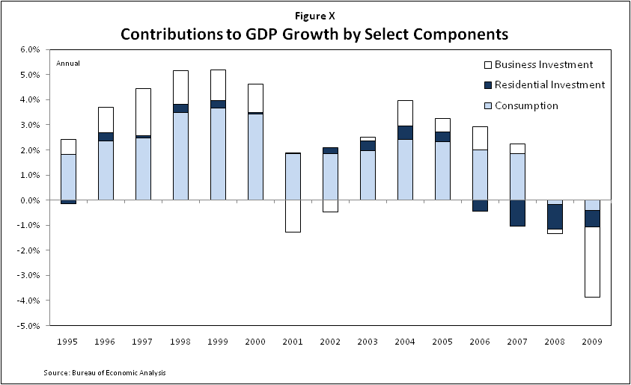

Speaking at the Federal Reserve’s annual Jackson Hole Symposium in 2005, Alan Greenspan, then Federal Reserve chairman, warned that asset prices may not continue to rise and that investors would eventually become less willing to “accept increasingly lower levels of compensation for risk.” HM: Very technical section, not too approachable to the average person Yet he remained optimistic that flexibility would let economic policy-makers respond effectively to a steep drop in inflated asset prices and minimize shocks to the markets. Not everyone agreed. Reacting to Greenspan’s speech, economist and New York Times columnist Paul Krugman was less optimistic in a 2005 column.

The U.S. economy is currently suffering from twin imbalances. On one side, domestic spending is swollen by the housing bubble, which has led both to a huge surge in construction and to high consumer spending, as people extract equity from their homes. On the other side, we have a huge trade deficit, which we cover by selling bonds to foreigners…One way or another, the economy will eventually eliminate both imbalances. But if the process doesn't go smoothly - if, in particular, the housing bubble bursts before the trade deficit shrinks - we're going to have an economic slowdown, and possibly a recession. In fact, a growing number of economists are using the *R* word for 2006. [WMT: Similar comment as before. Greenspan’s understanding of the current state of the economy could be relevant, because as a policymaker may have taken different actions if he had a different understanding. However, the purpose here seems to be dueling projections, which I think is something worth keeping away from. Further, if we do want to speak about current understandings, I’d prefer to keep away from specific individuals, because I’m sure there were others that agreed in part or in full, and I don’t see the need to single out one analyst vs. another. Further, in the Krugman quote, I don’t understand why the issue here was whether the housing bubble would burst before the trade deficit shrunk.]

The economy did indeed begin to slow in 2006. [KH: Wasn’t it near what most people thought was capacity at the time?  In other words, wasn’t slowing a good thing, otherwise we risked inflationary pressures?  And of course, “slow down” means “continuing to grow, but more slowly,” which is different than “shrink. **Recommendation:  Please source / back up this statement and show how close GDP / employment was to traditional measures of potential GDP / full employment.]** Nationwide house prices, which had risen an average 11% annually for five years, peaked early in 2006 and declined for the rest of the year. Although the economy as a whole grew at a solid 2.4% during 2006 as business investment and household spending held up, housing construction declined for the first time [since 19XX].[4] As shown in the chart, residential construction employment peaked in April 2006 [PA not clear from the chart that peak was 4/06 – need clearer chart or text change] and fell by [XX%] for the year.

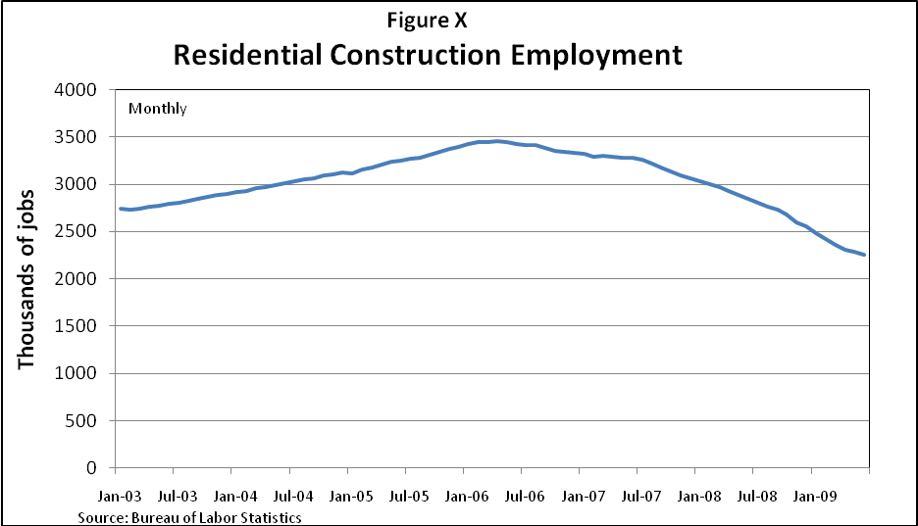

By the fall of 2006, concerns intensified. [KH: Please explain and source this statement.  *Whose* concerns?  Concerns *about what*?  If it’s just the FRBSF paper, I think that is insufficient. **Recommendation:  Strike this sentence or be precise.  I prefer striking it.]** The Treasury yield curve inverted in 2006 for the first time since the previous recession, one common sign of a coming recession.[5] [WMT: Particularly in cases where we are using a footnote to explain “jargon”, we need to make sure that the footnote is in plain English.] While there was much debate over the reasons for the inverted yield curve, a Federal Reserve Bank of San Francisco publication in November 2006 asked “Is a Recession Imminent?” and argued [brief description of the argument in that paper.] [Refer to other sources; explain monetary policy at the time.]

However, with the broader economy still growing robustly and the glut of foreign savings seeking haven in the U.S. [PA this is an example of where statements need to be supported by some data] many observers, including Fed Chairman Bernanke, argued that the probability of a recession during 2007 and 2008 remained low and that a “soft landing” was likely.[6] Indeed, through most of 2007, consumers, still awash in gains from earlier housing and stock-market appreciation, were able to spend enough to keep the economy growing. [Consider adding quote from the President’s Economic Report for 2008.] [WMT: Same comment. I think that it is better to state what happened and then add commentary, rather than the other way around.]

## Late 2007 through mid-2008: Some housing trouble, liquidity crisis and mild recession

The first hints of financial trouble [WMT: Although I understand that the mortgage market is subsumed in “financial trouble”, I think that this paragraph is really about weakness in the housing market (rather than financial markets).] emerged in late 2006 and early 2007 as more than 40 subprime mortgage originators failed, including New Century, one of the subprime market leaders. .[PA flesh out just a little, because NC wasn’t only problem, or defer details til later when you describe originator failures] During the winter and spring of 2007, policy-makers were primarily focused on the housing and mortgage markets, HM: we need to quantify how big these were [KH: Which policymakers? What’s the evidence for this? **Recommendation: Please provide more detail (not necessarily in the text). Which policymakers, and how were they expressing that focus.]** and Congress called officials from the Fed and other agencies to testify about housing policy, subprime mortgages, and the pain of the first big wave of homeowners facing the possibility of foreclosure. [Need some quotes here.] [WMT: It would seem that this paragraph would continue to discuss the weakness in the market, rather than jump to what Congress did, unless we think that some action by Congress had an important impact.]

The focus [WMT: The focus of what? Of the financial turmoil? Of Congress?] changed, [PA shifted? Or , The problems spread?], though, in the summer of 2007 with the collapse of the securitization markets. From the first week of August 2007 to the end of that year, over $400 billion in asset-backed commercial paper funding vanished. BB [Perhaps we should make it clear reason that it vanished was that lenders were not aswilling to lend.]HM: of how much? [WMT: What does this mean? We need to be careful not to make financial markets sound like magic, since it is our job to explain how they work.]This money had funded subprime mortgagesBG,jumbo mortgages, credit cards, auto loans and small business credit. The Fed started to lower interest rates and to provide additional liquidity, [ PA how specifically?], but by year-end the pressures on the real economy were becoming evident.

In his December 2007 testimony before the Joint Economic Committee, Chairman Bernanke described the situation:

“Concerns about mortgage-backed securities and structured-credit products (even those unrelated to mortgages) also greatly reduced investor appetite for asset-backed commercial paper, although that market has improved somewhat recently. In the area of business credit, investors shied away from financing leveraged buyouts and from purchasing speculative-grade corporate bonds. And some larger banks, concerned about potentially large and difficult-to-predict draws on their liquidity and balance sheet capacity, became less willing to provide funding to their customers or to each other.” [WMT: Is it important that we quote him here? Is there an actionable policy that comes out of this? Are we citing him as an expert? Is it important that he was testifying? Or, can we restate this in plain English and then cite him?]

[PA strike the next sentence]The financial hit [WMT: What financial hit? Can we get a sense of scope? Is this still a part of the testimony?] exacerbated the continuing decline in house prices, decreased residential investment and cut construction employment. DHE **[How did the corporate credit issues cause this?]** In his testimony [BG insert citation], Bernanke noted that GDP had continued to grow smoothly in the second and third quarter of 2007 and the economy might slow but perhaps not collapse [WMT: Did he explain why? If yes, then we should include this in order to give context to his understanding? Otherwise, it just seems like we are just putting this here to show that his projection was wrong.] PA However, the financial hit exacerbated the continuing decline in house prices, decreased residential investment and cut construction employment [how specifically did this “hit” cause the problems described?][KH: The use of “However” suggests that Bernanke was wrong.  But until September 2008, Chairman Bernanke was pretty close.  The last couple months of 2007 and the first eight months of 2008 were characterized by a slight recession – GDP was shrinking one or two percent per year.  This is worse than “slowing” but far better than “collapsing.”  In my view, NBER calling the recession as beginning in December 2007 was not a big miss by the Fed.  The big miss was failing to recognize the steady buildup of financial imbalances which resulted in the collapse in August-October of 2008.  And that wasn’t just Chairman Bernanke’s miss, but almost everyone else’s as well. **Recommendation:  Strike “However.”  Please react to my claim that the economy proceeded in three phases:  (1) pre-December 2007 growth; (2) Dec 07 – Aug 08 mild recession; (3) Sep 08 – at least mid 09 severe recession.  If you agree, then let’s characterize it that way throughout this section.  This concept will return in several comments below.**][KH: Let’s use titles for government officials, please, e.g., “**Chairman** Bernanke” **Recommendation:  Use titles for government officials throughout.]**.

. PA By December 2007, consumer spending was falling, business investment was slowing, and parts of the world economy were also weakening. [More detail on which parts of the world.] The National Bureau of Economic Research later determined that the economy was in recession by December 2007, citing broad declines in employment, investment and output.[7]

[Include cumulative losses at commercial banks and investment banks here – these stemmed from liquidity pressures in 2007, credit losses from their own holdings, and assets brought back on balance sheet during the fall. Chart of bank writedowns here.] [PA won’t we have done this in other sections re housing/financial crisis/] By early 2008, other credit markets became disrupted. Breakdowns in certain short-term funding markets in January and February 2008 increased borrowing costs for students and municipalities. [Include more detail on economy preceding Bear.] BB [Shouldn’t all this information on the history of the financial crisis be in earlier sections of the report rather than in the discussion of the impact on the broader economy?] [KH: I don’t remember any “breakdowns” in short-term funding markets until fall of 2008 after the financial shocks of September.  Did these markets “break down,” or was it just that interest rates and/or spreads increased?  There is a big difference between the two, in cause, in effect, and in the importance of the signals it sends to policymakers at the time. **Recommendation:  Please provide evidence of liquidity market “breakdowns” in Jan-Feb 2008, meaning that markets ceased functioning or otherwise behaved extremely aberrantly.  If by “breakdown” you instead mean “higher rates,” then please rewrite the text without “breakdown.”**]

The collapse of [BG 150 year old] Bear Stearns in March 2008 sent more shock waves through Wall Street, yet the US economy still remained seemingly unscathed. .[PA but we have noted that problems already developing, so unscathed not right]GDP (and maybe GDI BB [What is GDI? Is it gross domestic investement? We need to make sure that we use terms that are understood by the general public.])DHE **[need? Care?]**) actually grew in the first and second quarters of 2008, albeit sluggishly, supported by gains in [XXX].

Lower interest rates and the increased liquidity provided by the Federal Reserve had so far forestalled a major collapse in the economy. [KH: This suggests that the collapse was inevitable, and that it was delayed by the lower interest rates and increased liquidity. How do we know this is the case, rather than instead that it took until fall of 2008 for the imbalances to build to the point where they were unsustainable? This seems to be an unprovable claim about the counterfactual situation. **Recommendation: If there is evidence to back this claim up please provide it. If it is instead a belief about the counterfactual then we should strike it or at least debate it before including it.**] Payrolls in the first half of 2008 were falling at a modest pace, consistent with previous mild recessions, and by July the unemployment rate had risen to only 5½ percent. HM: Number of people out of work

[Discuss the rise in commodity prices and in particular, oil which peaks at this point.] BB [This is an important part of the story; I think mention of the spike in agriculture prices should also be included. Sen. Levin’s committee produced a relevant report on the spike in winter wheat prices. I notice that there is no discussion of the spike in securities prices; I think that that is also relevant.]

## September 2008: Financial crisis hits hard

The shocks to the housing markets finally exploded into the broader economy in September 2008. Fannie Mae and Freddie Mac went into conservatorship. Lehman Brothers declared bankruptcy. AIG [BG the oldest and the world’s largest insurance company?] was bailed out by the Fed and Washington Mutual and Wachovia [BG size of institutions?] were acquired at fire-sale prices when reluctant lenders refused to let them borrow enough cash to continue operating [WMT: They were acquired because they experienced a depositor run and they became failed banks. I think that the current structure makes it sound like their failure was caused by the fact that they couldn’t get additional funds in the capital markets.]. [PA failure was for broader reasons]The interbank lending markets effectively froze and the unsecured commercial paper market seized PA up for all but the firms perceived to be most creditworthy. Even those firms could only borrow at high rates and for a day or two at a time. As banks and investors hoarded cash, credit nearly vanished and the economy was on the verge of collapse. DHE **[This is breathless, but analytically vacuous and too typical of this chapter.]**HM: Need first person stories here and below

As the President’s Economic Report noted in 2010 BG that, DHE **[we shouldn’t be citing any ERP – they are political documents]**, things got even worse after September 2008: “Over the final four months of 2008 and the first month of 2009, the economy lost, on average, a staggering 544,000 jobs per month—the highest level of job loss since the demobilization at the end of World War II. Real GDP fell at an increasingly rapid pace: an annual rate of 2.7 percent in the third quarter of 2008, 5.4 percent in the fourth quarter of 2008, and a heart-stopping 6.4 percent in the first quarter of 2009….All told, the world economy is expected to have contracted 1.1 percent in 2009 from the year before—the first annual decline in world output in more than half a century.”[8] [WMT: What not use our own language?] [KH: It is dangerous to quote The Economic Report of the President, given that it’s released by an Administration and it represents a particular view of the world and a particular policy agenda.  If we are just providing economic data, then let’s provide that data without quoting the ERP.  If we are going to quote a President/Administration, we should lean toward doing this for statements about policy, policy intent, or their analysis of the economic/financial situation and how it affects their policy prescriptions, rather than their particular presentation of data. **Recommendation:  On page 13, strike the ERP reference and instead just provide the data/facts.]**

# U.S. Economic Pain: The link between the financial system and specific sectors

[The housing crisis and the credit crisis produced a downward spiral. As the financial markets went into crisis, consumers and businesses couldn’t get financing for their spending and investing activities, resulting in lower confidence and less credit creation, etc.]

## BB Lending to BB business dries up [WMT: I’m not sure that this section needs so much play-by-play, especially to the extent that these topics are raised in Section III.]

BB [I think we need to discuss in much greater detail how the credit crunch’s decrease in lending led to decreases in production and spending, lay offs of workers, bankruptcies, etc.--that is, the impact on the economy of the decrease in lending. It seems to me that the primary focus now is on the lack of borrowing rather than on the results of that lack. Also, I think we need to focus on other factors impacting business such as the fall in asset values and investments.]

[This section will discuss large business and then small business.]

### Large business lending

The credit crunch made borrowing difficult for large businesses and increased their uncertainty about the future. DHE **[Measured how?]** [KH: Did the credit crunch “increase [large businesses’] uncertainty about the future”? I would have thought that other factors would have been more responsible for increased uncertainty (e.g., market volatility, the severity of the decline in the real economy, and policy uncertainty – more than just credit tightening.) **Recommendation: Please support or strike this language.**] During the 25 years leading up to the crisis, businesses had come to rely more and more for their financing on the capital markets - commercial paper, securitization conduits, repos, and other financial PA instrucments rather than just on traditional banks [PA another example of where we need hard data]. BB [ and less and less on bank loans?].

When the financial panic hit [WMT: This makes it sounds like the panic was something done to the system] in September 2008 after the collapse of Lehman and AIG, *all* forms of financing began to dry up. Since large corporations rely on capital markets and commercial banks for short-term funds for daily operations, holding inventory, and meeting payroll expenses, and also for long-term financing to build plants and invest in technology, they now found themselves relying on cash for short-term needs and reevaluating their long-term plans.

BB [I think it would be useful in this subsection to quantify the various sources of funding relied upon by business and demonstrate how each of them contracted during the crisis. For example, a comparison of the amount of commercial paper, bank loans, syndicated loans, corporate bonds, etc.]

[KH: I am confused about the order and prioritization.  Why give syndicated loans more prominence than regular debt and commercial paper?  Also, I thought I remember that plain vanilla lending by high-quality corporate borrowers was more expensive but still flowing fairly steadily.  Is that true? **Recommendation:  Explain the prominence and sequencing of syndicated loans, or reorder and reprioritize:  corporate debt – cp – syndicated loans.**] Important parts of the syndicated loan market – an important source of credit for large corporations HM: size of market?– became severely constrained. [WMT: Chronology. Did syndicated loans dry up in September 2007 or 2008?] The amounts of money that many companies need are often too large for any one bank to provide alone, as banks will limit their exposure to individual borrowers. In the syndicated loan market, a lead lender/arranger (typically a money-center bank) will find a group of lenders—sometimes just a few, sometimes more than 20—to lend to the business. [Include some examples of actual loan deals from 2007 here, including some term loans, possibly M&A, and some revolving lines. Many of these are quite famous such as the Countrywide $11 billion line of credit, the $23 billion deal for First Data, etc. Will choose the best ones for the narrative.] [PA hopefully ones most relevant to the collapse]

Many loan syndications are longer-term loans, often for five years or more, used frequently to fund investments or for merger and acquisition activity. Other syndicated loans are revolving lines of credit – effectively credit cards for large and medium-sized corporations corporations – PA providing funding availabilityto a borrower as long as the borrower remains in compliance with the loan covenants. [WMT: “Unfunded commitments”, “loan covenants”, this section has a lot of borderline technical language that can be simplified.] Some of these lines of credit are for working capital or inventory: however, some are so-called back-up lines of credit to make sure that businesses can fund their commercial-paper programs. If a company is having trouble repaying its commercial-paper loans and [PA or] cannot access the commercial paper market again, it can draw on this line of credit to come up with the cash.

Just as the crisis was PA developing in the summer of 2007 [WMT: Is this jumping back a year?], and the commercial paper market HM: size?and repo markets HM: size? were coming under stress, the syndicated loan market also began to contract. During the peak of the market in the second quarter of 2007, lenders issued nearly $600 billion of new loans. In the first quarter of 2008, that PA declined 70 percent to $180 billion. In the fourth quarter of 2008, that number plummeted to $100 billion. Lenders, and in particular non-bank lenders such as hedge funds, pension funds and leveraged loan managers of collateralized loan obligations, cut back. [Will add CLO issuance from ABAlert and quotes from interviews with LSTA.] In addition, some of this drop resulted from a decline in refinancing activity and some was a result of decreased demand, in particular for loans related to merger and acquisition activity. .[PA example of where we need facts to support a statement]

Similarly, PA amid market uncertainty, corporate bonds PA faced rising interest rates and PA became moredifficult to issue; corporate bond issuance fell to $[XX] in the fourth quarter from $[YY] in the second quarter of 200X. While corporate bond issuance for relatively low-risk firms has recovered somewhat since then, issuance of bonds by less credit-worthy firms remains limited [BG as perhaps is should???].

By mid-2007 [WMT: Two paragraphs ago we were talking about the summer of 2007. We should be clear if mid-2007 Is contemporaneous or after?], U.S. commercial banks were beginning to restrict access to credit for large and medium businesses. In fact, the Federal Open Market Committee noted the tightening of business credit conditions in its September 18, 2007, announcement lowering the federal funds rate by 50 basis points [describe more]. The tightening in business credit stemmed from the initial troubles in the asset-backed commercial paper market in 2007. BB [Are we maintaining that the problems with ABCP caused other credit tightening or that they were the first manifestation of the credit crunch?] .[PA only reason?] Interbank lending rates spiked in August 2007 [WMT: I think that a chronological approach here is better (August 2007 is after September 2007)] as concerns surfaced about banks needing to provide credit and liquidity support to these programs. In addition, banks became less willing to lend to each other given the increased uncertainty BB [We should say what the uncertainty was about.]. They began to build their own cash positions BG ass they PA might face difficulty in raising funds in wholesale funding markets. As costs of funds rose and banks hoarded cash, BG many banks were less willing to lend to corporate customers as well. These events were somewhat slow to kick in fully. DHE **[Events don’t “kick in”]** As the chart below shows, evidence from the Federal Reserve’s Senior Loan Officer Survey shows that banks *en masse* didn’t begin to tighten terms on commercial and industrial business lending until 2008. [PA this last sentence in paragraph doesn’t square with the first]

By September 2008, commercial and industrial lending PA had become tightly restricted While lending by banks in fact spiked in September [chart will be rescaled to show September], the spike is an anomaly PA as firms drew down on their existing lines of credit. BB [This seems confusing. Is our argument that lending spiked because of the drawing down of lines of credit but in other respects lending was decreasing? It appears as though there was in fact a great expansion of lending in 2008.]DHE **[You don’t do anything w/ the debate – distracting]** [WMT: I think this is more confusing than it needs to be (as interesting as the “spike” is). Can’t we just say that firms drew down their lines of credit because they no longer had access to commercial paper markets and leave the chart out of it?] PA They did so for several reasons: First, they were worried about access to credit markets in the future; second, they owed payments on existing debt in the commercial paper markets that they were unable to roll over; and, third they may have PA needed cash. Companies such as Marriott Corp., Delta Airlines, and Duke Energy borrowed against their lines of credit, where once they had ready access to commercial paper for short-term needs.[9] [Insert better evidence.]

[Will replace chart with shorter time frame and different scale to highlight patterns of lending during the crisis.] [PA/BG typo – commercial]

For firms that could roll over their commercial paper, this debt became more expensive or shorter term. Rates spiked for these borrowers to [PA by?] nearly 3 percent BB [from X percent]. Spreads over Treasuries (the difference in the cost of borrowing compared to safer Treasuries) increased to [YY]% at the end of September from [YY%] at the end of August.

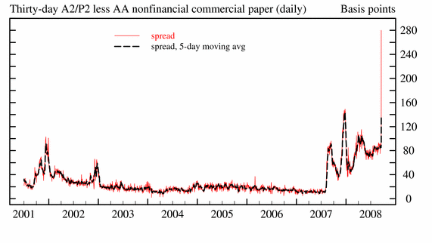

[Need to explain this chart] [WMT: Can this chart also be made a shorter time interval and have it continue past the fall of 2008.][BG and continue into 2009 at least]

The introduction of the Commercial Paper Funding Facility in October 2008, under which the Federal Reserve would lend directly to non-financial entities for the first time, allowed the commercial paper market to resume functioning at more normal rates and terms. BB [We might make it clear that the CP market did not really return to normal since the Fed had stepped in in place of the normal lenders.][Add in details on who used this facility.]

Even with the Commercial Paper Funding Facility, however, BB credit to businesses remained tight. In the fourth quarter of 2008 nearly 70% of banks said in the Senior Loan Officer Opinion Survey they had tightened credit standards and lending. Much of corporate America was left with restricted access to credit.

[This section will explain government programs for the large business sector including the CP programs.] [Some of this is redundant with the above and will be streamlined.]

As credit options shrank for large companies, there were serious economic impacts from the financial markets for the first time in 25 years. BB [I think we need much more focus and details on these impacts. [PA assume you are referring to high interest rates of early eighties? If so, may want to make explicit – e.g for the first time since …][KH: What about the near collapse of LTCM in the 90’s, or the Asian debt crisis?  Why don’t those fit?  Both are within the past 25 years. **Recommendation:  Please support or strike/modify this statement.**]

The credit crunch forced some corporations to lay off workers or reduce their investment, reducing [BG different word] potential productivity improvements and inhibiting growth. A survey of CEOs found 81% of U.S. companies had to reduce capital investment and technology spending.[10] DHE **[No footnote]** [We will insert examples of specific businesses that faced troubles during this time.] [PA and data] Some businesses could not cover short-term expenses such as payrolls and the financing of inventory. [Insert examples of inventory-related problems. Auto for example.] HM: real examples

Business people worried about the entire shadow banking system collapsing. [KH: Why does “shadow banking” apply here? Wasn’t there fear of commercial banks collapsing as well? If so, then the statement should be broader than just “shadow banking.” Also, I think the term “shadow banking” is value laden and political. (I am not critiquing anyone’s intent by including it here, but I suggest striking it from the draft.) **Recommendation: Recharacterize this sentence so that it is broader than just “shadow banking.” (e.g., replace “shadow banking” by “financial”) And where we mean large financial institutions other than c-banks, let’s find another less value-laden term.**] The senior vice president for finance and treasury for Devon Energy Corp., told the FCIC staff that had it not been for the Commercial Paper Funding Facility, “We would have been eating grasshoppers and living in tents. Things could have been that bad.”[11] [WMT: I’m concerned that there’s not enough “real economy” here. I think that adding quotes and narrative where possible will be useful, but the section seems very impersonal, about indicators of financial market strain, rather than real businesses.] [PA as with rest of Section 4, needs to have more real examples, data, regional information that ties what’s happening in financial markets to the real economy, real businesses, and real people].

### Small business lending BB [Again, I think we focus too much on lending and not enough on the effects of the credit freeze and loss of asset value on small businesses and ultimately on the economy.] [WMT: We need to make sure these are all apples-to-apples comparison for small business statistics]

[Introduction: Small businesses were especially [BG hard] hit by the financial crisis because some rely on the most impaired parts of the credit markets and small bank lending.]

#### Sources of credit

Small businesses are a critical engine of the American economy, with over 6 million of them accounting for about 45% of private-sector payrolls HM: number of jobs and just over half of employees. HM: number of people[12] [PA when it comes to jobs in particularly, we need real numbers not just percentages]. By some counts, small businesses accounted for more than half of all new jobs over the past 10 years, and nearly 80% of all new jobs in 2004 and 2005 HM: actual number s- percentages aren’t as powerful [WMT: Is this net or gross?]. Moreover, small businesses produce about half of the nation’s private, non-farm GDP. [Congressional Oversight Panel; will find other sources.]

Small businesses get credit from traditional banks, other financial institutions, non-financial companies or personal borrowing by the owners. The financial crisis disrupted all these sources, making credit scarcer and more expensive in the past few years. [Note that small businesses have fewer options than larger companies and cite a source.]

Traditional loans from banks are the primary source of credit for small businesses. The last Survey of Small Business Finance, conducted by the Federal Reserve Board, shows 60% of small businesses had a credit line, loan or capital lease, nearly half from banks.

Small businesses typically borrowed anywhere from $140 to $170 billion annually in new loans from banks in the years preceding the crisis.[13] .[PA data or chart]

In 2008, bank credit collapsed for small businesses too as banks tightened credit standards and in some cases stopped lending altogether.[KH: You mean post-August 2008, right?  If so, let’s say that. **Recommendation:  Insert “late” or “Q4” like this:  “In late 2008, bank credit collapsed for small businesses too…”]** The Senior Loan Officer Opinion Survey showed that the number of banks tightening standards on loans to small firms rose dramatically during the crisis.

Many small business owners raise money by borrowing against their personal assets, including real estate. According to the 2003 Survey of Small Business Finance, 15 percent of the value of small business loans was collateralized by personal real estate. [Source: COP.]

The National Federation of Independent Business found in 2008 that 22 percent of business owners surveyed had taken out at least one mortgage to fund business activities. As house prices fell, PA real estate equity evaporated and banks tightened mortgage lending standards, small businesses found BG another source of credit had vanished.

Other sources of loans for small businesses are credit-cards loans and loans guaranteed by the Small Business Administration. Both rely in part on the securitization markets. When those markets contracted in 2008, credit from these channels became constrained. [Insert chart on ABS here.] Securitization of credit cards – an important credit instrument for small businesses – slowed down in 2008 [pull fact from household section]. BB [Did securitization slow down because there was less credit card lending or did the slowdown cause less lending? I’m not clear about the causal link we are trying to describe.]

And card issuers got more stringent at the same time. In the April 2010 Federal Reserve Senior Loan Officer Survey, a majority of banks indicated that their standards for approving credit-card accounts for small businesses were tighter than “the longer-run average level that prevailed before the crisis.” Banks had continued to tighten “their terms on business credit card loans to small firms – for both new and existing accounts – over the past six months.”

The small-business-loan securitization market dried up in October of 2008 and there was no issuance of small-business loan securities in 2009.[14] [More detail on SBA loans.] [PA What direct effect did this have on small business lending?]

Finance companies, another major source of financing for small businesses, were also constrained during the financial crisis. As of 200X, 20% of small businesses used such companies for their credit needs. In order to raise money to lend to businesses, these independent finance companies often funded themselves by issuing commercial paper in the capital markets. When commercial paper dried up during the crisis, some active lenders to smaller businesses, like GE Capital, were able to continue financing their operations, BG but at a reduced level [insert quote from GE hearing] but others had severe trouble.

CIT was one such firm. “Worries … cascaded through the retail and manufacturing industries …, as companies stopped shipments and businesses worried about cash being tied up at the lender should it file for bankruptcy-court protection. (WSJ_7/17/09)” [Need to tie this quote to CIT and explain “cash being tied up.”]

CIT was approved by the Federal Reserve to become a bank holding company in December 2008 after raising [$XXbn] in new capital. Even with $2.3 billion in additional capital support from the federal TARP program, CIT was forced to file for bankruptcy in November 2009, but quickly emerged in December through a prepackaged plan of reorganization. [KH: It is strange to include CIT in the small business lending section, given that CIT’s failure was a medium-sized inflection point in the crisis.  CIT’s bankruptcy, government *not* stepping in to intervene, and the non-event that followed were a significant marker point during the crisis.  To include CIT here where we are trying to discuss small business loan tightening distracts the reader from the point of this section. **Recommendation:  Remove the CIT references from this section.  If the CIT conversion/bankruptcy story is important, let’s include it elsewhere.**]

[Explain what happened in small business lending market when CIT failed and other firms pulled back. The type of lending these guys do is relationship heavy and very intense monitoring. One cannot just go to another lender – when CIT collapses bad things happen. Will explain how trade credit, which also depends on the commercial paper market, could not take up the slack.] **[**There are a lot of quotes available here from the commercial finance credit association.]

[Need a wrap-up paragraph stating that small businesses lost their major sources of financing and are still struggling.]

As small businesses began to suffer, the government made several attempts to improve their access to credit and to help them weather the financial and economic crisis.

One 2008 effort was the Term Asset-Backed Securities Loan Facility, or TALF, a program of the Department of the Treasury and the Federal Reserve Board. They designed the program to bolster securitization markets for credit-card loans, Small Business Administration loans and other loans that small businesses use.[15] While SBA loans are a small portion of small-business lending – only $13 billion in 2009 compared to hundreds of billions of dollars from all sources – they nonetheless are an important source of funds for small businesses DHE **[measured how?]** unable to access other credit markets. [KH: TALF is characterized as a small business assistance effort.  While small businesses indirectly benefited, the purposes and uses of TALF were far broader. **Recommendation:  Whatever we decide on policy actions should apply here as well.  If we are going to discuss policy actions, then we need a broader discussion of TALF somewhere.  We can’t have the only TALF reference in the report be about its benefits for small business lending.]**

TALF, though, was only one aspect of the federal effort to assist small business during this turbulent period. A section of the American Recovery and Reinvestment Act, the stimulus bill, attempts to recapitalize small banks so they can continue lending. And through other programs, the government attempted to bolster small business lending.

Still, the prevailing winds made for slow sailing for small businesses. According to the Federal Reserve’s Survey of Terms of Business Lending, in 2009 interest-rate spreads on relatively small loans – between $100,000 and $1 million – rose by about 100 basis points points [ PA always inclined to use % if possible feasible] from a year earlier, their highest level in more than a decade. HM: What does this mean in real terms? Eg small business had to spend xx more $ on paying their loans and had less to spend on hiring….

Chairman of the Federal Reserve Bernanke said in a July 2010 speech that getting a small-business loan was still “very difficult.” He also noted that BG bank loans to small businesses dropped from more than $710 billion in the second quarter of 2008 to less than $670 billion[16] in the first quarter of 2010.[17] BB [This seems like a relatively small drop in lending and doesn’t seem to demonstrate a drying up of lending. Again, it would be useful to show the amount of funding for small businesses from each source and the effect on that source of the credit crunch.] [PA doesn’t seem very percipitous]

Credit remained tight because there was more at play than simply the disruptions in the financial markets. For instance, lenders were unwilling to make loans to small businesses BG because business lending seemed to be riskier than before the crisis. BB [Why did they seem riskier? Wasn’t it because of the financial crisis?] In addition, sluggish economic conditions and an uncertain outlook BG also damped small BG business demand for loans PA.

C. R. “Rusty” Cloutier,president and CEO of Midsouth Bank in Lafayette, La, stated in testimony to the FCIC on behalf of the Independent Community Bankers of America: “Community banks are willing to lend, that’s how banks generate a return and survive. However, quality loan demand is down… I can tell you from my own bank’s experience, customers are scared about the BG economic? climate and are not borrowing. Credit is available but businesses are not demanding it.”[18] HM: I liked Rusty, but this is a self serving point of view, and I am not sure it is totally accurate, so I am not sure I would keep it. [WMT: Given that he’s testifying on behalf of community banks, he might not be the best source.][KH: Strike the Rusty Cloutier paragraph.  We debated whether interest group representatives should be allowed to testify, and the Chairman said in retrospect we should not have invited Cloutier to testify given his role in the ICBA.  I’m OK citing interest group representatives in that role.  I am uncomfortable citing them as if they are impartial analysts or observers.]

Even so, surveys and anecdotal evidence suggests that creditworthy borrowers with a desire to borrow are facing tighter credit markets than before the crisis. [We will support this with case study evidence.] [PA and perhaps another expressed viewpoint in addition to Cloutier]

Without access to credit markets to help weather the crisis, small businesses PA ranthrough their cash in reserve, had trouble paying bills and BG face rising bankruptcies and loan defaults.

Defaults on small-business loans increased to 12% in 2008 from 8% in 2007 [need more history here].[19] More than 100,000 small businesses shut down or laid off significant numbers of people in 2009, about 30% to 40% higher than previous years.[20] [Compare this to large-business layoffs.] Overall, the current state of the small business sector is a critical factor in the struggling labor market: ailing small businesses are laying people off in large numbers, [PA present tense], and stronger small businesses aren’t hiring additional workers. BB [It would be useful to have more information on the impact of the credit crunch on reduction of production, spending, bankruptcies, layoffs, etc. and the resulting effects on the economy]DHE **[I have 2 objections to this. 1) If lenders are currently pricing risk accurately and it is higher, then this is exactly what should be happening and is unrelated to the crisis. 2) Why are we opining on the current state of the small business sector and not the crisis?]** .[PA seems like this info re defaults, lay offs, etc needs to come earlier. We’ve described financial events that triggered problems in great detail, and paid too little attention to real consequences.]

[Will add regional facts on small businesses, including case studies from the field hearings if possible.]

## Unemployment

BB [We need to describe what caused this unemployment. The suggestion that unemployment preceded the financial crisis seems unexplained: are we suggesting that unemployment was the cause rather than the result? If so, I don’t agree. I think we should link the unemployment with the fall in production related to the inability of business to borrow and the loss of asset values by business. Further, we need to describe the implications and effects of the unemployment on the economy--for example, the cut-back in consumer spending.] This economic crisis has set a number of historic records in the labor market. In the twelve-month period ending in December 2008, the economy shed 3.6 million jobs, the largest drop since records started being kept in 1940 (see the chart below). [KH: Job loss in the first eight months of 2008 was very mild, and in the last four months of 08 and the first six months of 09 was far more severe.  We should describe this, rather than using figures which treat 2008 as it if were all of a piece. **Recommendation:  On page 26, replace the second sentence in B. Unemployment with something like, “Job loss in the first nine months of the recession beginning in December 2007 averaged X,000 jobs per month.  The financial shocks beginning in September 2008 caused/were associated with far more severe job losses, averaging Y,000 jobs per month through [month] 2009.]** By December 2009, the economy had lost another 4.7 million jobs. While the population has of course grown over time, the change is still stunning. DHE **[Define “stunning”]** The so-called under-employment rate, which measures the unemployed, those part-time workers who would prefer full-time work as well as discouraged workers, rose to 13.7% in December 2008, the highest level since calculations for that measure began in 1994. HM: How many people is this? In May 2009, the length of time people have remained unemployed hit the highest level since records started being kept in 1948, and it has continued to increase (shown in the chart below). [PA We need to make this more vivid, real, graphic [verbally so}. Real numbers not just percentages; referencing the breadth of impacts – those places with high double digit unemployment; the number of jobs per applicant; unemployment among certain populations, like young African Americans, young folks coming out of college, older workers laid off, etc.]

[PA We also need to be more specific about where the job losses have been – sectors and regions. For example, big drops in home construction/employment; same in commercial – tie the thread of financial crisis and economic crisis together. In fact, now that I mention it , while we look at impacts (not limited to employment) on large businesses, small businesses, educational costs, we don’t spend any time on couple of key sectors such as residential construction].

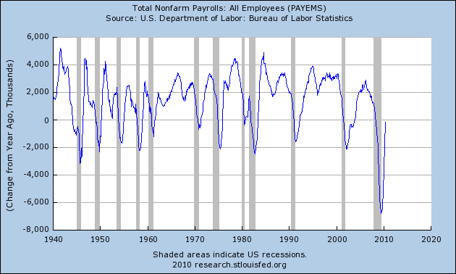

The pain in the labor market has its origins in developments in the US economy before the financial crisis. BB [Here is where we seem to be suggesting that unemployment may not have been caused by the financial crisis; I strongly disagree.] HM: how many jobs existed before? [PA this needs clarification]. Indeed, the labor market began to slow in 2007, well before the financial crisis was in full force. As was discussed early in this section, the economy was likely poised for recession in 2006. DHE **[20-20 hindsight and not obvious.]** [PA this also needs clarification/amplification][KH: I have serious concerns about this entire paragraph.  Please see my comment in (30) about the two time segments of job loss. Please see my comments about “the economy was likely poised for recession in 2006.” **Recommendation:  Strike at least the first three sentences of the paragraph on page 27.  If others disagree then we need to discuss this as the commission level.]** Nonetheless, the layoffs and very weak hiring by businesses that were cut off from credit markets and uncertain about future financial conditions BG made the labor market much worse. In addition, as households began to pull back on spending (discussed later), businesses were further hurt, which led to further layoffs. This sort of downward spiral [KH: “downward spiral” confuses me.  Isn’t that just a description of a traditional macro contraction?  Also, please support:  household spending à firms laying off workers.  I know that net employment dropped tremendously.  Did firms fire many more workers in late 2008, or was it a severe decline in hiring? **Recommendation:  Strike this paragraph or rewrite it.]**has generated extraordinary pain for American workers.

[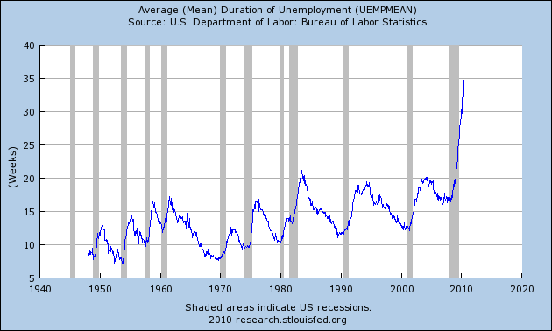](http://research.stlouisfed.org/fred2/graph/?s%5b1%5d%5bid%5d[1][id]=UEMPMEAN")

[More discussion of this particular crisis and the labor market: survey evidence that firms don’t want to hire in the uncertain environment; businesses are hoarding cash rather than expanding; discussion of government efforts to boost the job market. Additional regional effects.]

This crisis has created some atypical problems in the labor market. For example, homeowners who are “underwater” may not be able to afford to sell their homes and move to where the jobs opportunities are. Selling a home when more is owed on a mortgage than the market value of the home requires coming up with additional money to pay the lenders, unless a lender is willing to do a short sale or the homeowner defaults. Measures of labor mobility, such as population movements across state lines from the Census, show that labor mobility has been lower in this recession than in previous recessions. [Will provide data.] The effect of this decline in mobility will be a slower return to full employment in the US economy. [Will show regional impact including a map.] [PA don’t know if regional impact referred to is impact re lack of mobility or unemployment generally. Both would be good – a national map with unemployment rates is a good graphic.][KH: I find the mortgage lock-in / underwater / decline in labor mobility / slow employment recovery story to be plausible, but if it’s true we need more than plausible, we need evidence.  We can’t just assert it.  Also, the word “may” is a red flag that we might not be able to back up this story. **Recommendation:  Let’s see some concrete evidence that backs up this hypothesis.  If it exists, I’m all for including this argument.  If not, we need to heavily caveat this and instead indicate that it’s a hypothesis that we cannot prove or disprove.]**

The economic crisis will also do significant longer-term damage to wages. DHE **[Average wages? How? Will compensation not match productivity because of a past crisis? Why?]** [WMT: I’m not sure that it is our place to talk about projections forward from 2010.] For example, studies show that, on average, workers’ lifetime incomes never recover from being laid off during a recession. DHE **[True and absolutely unrelated to having a financial crisis. Why is this here?]** One study looked at the wages of men who lost their jobs in mass layoffs during the 1982 recession, Even 15 to 20 years after being laid off, their earnings were about 20 percent lower than those of similar men who weren’t laid off. [Will show anecdotal info on people going back to work, e.g., Von Wachter, Song, and Manchester.] [PA it would be good to have some info, even anecdotal re this recession. I know a number of people in my home region who have gone back to work for a lot less $. Careful re projecting the future, although citing research re past recessions is ok – e.g if history is any guide, the economic crisis may also do….]

PA There will also belong-term effects for those just entering the job market. DHE **[Same comment – has nothing to do with financial crisis.]** One study on the long-term effects of recessions shows that college graduates entering the labor force during weaker labor markets make less over their lifetimes than other college graduates. The reasons for the difference includes a lower initial wage when graduates enter a weak job market, a poorer initial match between a graduate’s skills and interests and the job, as well as fewer opportunities for training and promotion. (Kahn; also see studies by Oreopolous, and Bowlus and Liu.) And, the effects aren’t just economic. A large and long-standing body of research shows that physical health tends to deteriorate during unemployment, most likely through a combination of fewer financial resources and a higher stress level. (e.g. Till Von Wachter and Daniel Sullivan) [PA again, try to make this kind of info referred to in this paragraph real and related to this crisis, in addition to academic background. Also, careful re wording on the future, but fine to cite historical as noted above].

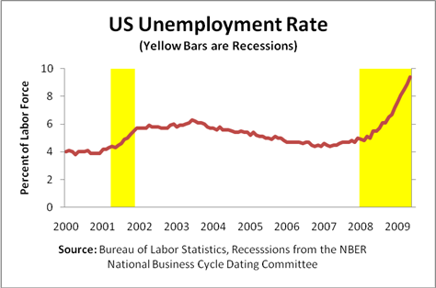

## Impacts on households

Over the course of the economic crisis, households have been buffeted by many headwinds. [KH: In my experience, the “headwinds” term is generally used when the economy is growing but slowly.  It’s not used when things are getting worse.  But from September 2008 to at least mid-2009 (if not longer) the economic situation of households (at least in the aggregate) was probably getting worse, no?  At least employment was still declining until at least the second half of 2009. **Recommendation:  Find a stronger negative phrasing than “buffeted by many headwinds” to describe the economic situation of households from late 2008 through at least mid-2009.]** Job security has diminished; DHE **[how do you measure “job security?”]**; wages have suffered; the rise in home prices on which many people borrowed or banked their retirement has reversed; the stock market has fallen from its peaks, and credit remains harder to get.

Measures of consumer confidence show people are very anxious about the future. Consumer spending has declined sharply, even after government stimulus programs. [Will specify.] HM: Foregoing college? Domestic violence? Divorce? Child abuse? Suicide? There have been several high profile instances in our community - although the sheriff tells me that crime is down which he attributes to families needing to depend on each other more.

The shambles DHE **[huh?]** [PA instead of shambles in – “impact to”]in the job market has devastated wages. DHE **[Are they crying? What does this mean?]**.[PA instead of devastated wages – “hit wages hard”.] In 2009, nominal personal income fell 1.7%, the first drop over a full year since 1949 and the worst drop since 1938. Since 2009, wages have gained a little [but are still well below levels before the recession began]. [Will include regional and other detailed effects.]

In recent recessions, households have used credit – such as credit-card loans – to help smooth rough times. This is one of the reasons a credit market is so vital to an economy. However, during this recession, many consumers wanting to borrow found it more expensive and harder to do; others may have sought to reduce their debt burdens due to uncertainty about their future income. [Fed credit card profitability survey.]

[Will insert paragraph on the effects of lower wages on households and spending.] [ PA seems likes this should go before above paragraph]

### Impacts on wealth

[KH: We need a much more extensive discussion of the effects of the housing market problems than what is in draft #1 of this section. **Recommendation:  Expand the discussion of the effects of the housing market problems.]** Households entered the recession with large debt loads financed in part by increases in home prices. From 2000 to 2006, household debt nearly doubled to $13 trillion. Nonetheless, given gains in house prices, and, to a lesser degree, stock prices, households’ net wealth —the difference between what they own and their debt—rose nearly $22 trillion [PA also %) over this period to a peak of $[XX] trillion in [quarter of 2006] [WMT: What was the impact on debt as a percentage of wealth. If wealth goes up, we’d expect to see an increase in debt, no?]. The collapse of the housing and stock markets erased much of the gains but, of course, left household debt untouched. .[PA this does not square with later statement that debt has come down some][KH: How important was the aggregate decline in housing wealth relative to total wealth?  I thought I remembered that the total loss of wealth in the housing stock, while large, was smaller than that occasionally experienced when we have a really bad day (but not a crisis day) in the stock market.  If this is true, then we need to understand and explain this, and why the effects of an X% decline in total household wealth that occurs through housing is more economically damaging or painful than the same size wealth loss that occurs through equity markets. **Recommendation:  Staff should analyze/compare the loss in total household wealth to determine the equivalent size equity market decline and evaluate whether the problem was the decline in total household wealth or something else instead.]**

The effects are stunning: From the peak in mid-2007 to the low point in early 2009, household net wealth fell $17.5 trillion, or more than 25%. Despite firmer stock and house prices and a decline in household borrowing since early 2009, as of the third quarter of 2010, net worth is still $12.5 trillion below its peak, as shown in the chart below.

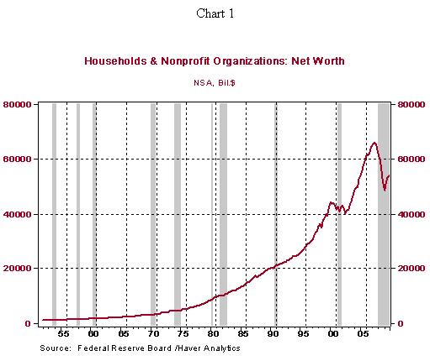

Leading these declines, nationwide house prices dropped [nearly] 30% from their peak in 2006, according to the Case-Shiller house-price index. [Earlier chapters discussed the national foreclosure crisis and the destruction that foreclosures have wreaked on both homeowners and renters. Here, we focus on the effect on spending of the steep drop in household wealth from declines in housing prices and sales.] With nearly 70% of households owning a home before the financial crisis, these house price declines have had PA significant implications.

The decline in real estate wealth has made it harder to borrow. In the past few decades, one reason homeownership had become more attractive was that lenders were willing to lend to households against their equity. PA Now an estimated 20% of households owe more on their mortgages than BG their homes are worth, effectively shutting off home equity loan or cash-out refinancing as a backstop for households. [BG In some markets, such as Southern Nevada, the percentage is much higher, as high as 70%????]

The stock market has also fallen. While stock ownership is not as broad as home ownership, it has also caused pain on Main Street. The Dow Jones Industrial Average fell nearly 50% from PA its peak in May 2008 to its low in March of 2009. Stock market shares directly held by households declined some $3.5 trillion and years of savings vanished in a few months. [Will update figures.] BB [Discussion of loss of retirement savings should be included here.]

Many baby boomers have postponed retirement after seeing their savings vanish during the financial crisis. [Will provide data.] DHE **[I doubt it because you can’t measure “postponement” and “vanish” means literally zero.]**HM: this is very important. Older people are extremely anxious.

### Mortgage-market shock

As households became delinquent on their mortgages, mortgage originators began to lose money and go out of business, starting with Ownit Mortgage Solutions in December 2006. .[PA Is this really the reason that originators collapsed? Or was it because the mortgage market collapsed, their lines weren’t renewed, etc – let’s be precise] As these companies disappeared, mortgages became unavailable, DHE **[There were ZERO?]**, [PA totally? Or dramatically pared back?], leading to further house price declines and, eventually, further disruptions in spending. BB [Again, I wonder about the causation. Did the failure of mortgage originators make mortgages unavailable, or did they fail because the mortgage market dried up? I assume the latter.] Most independent subprime mortgage lenders that relied on securitization markets for their funding failed or were acquired in 2007.

New Century Financial filed for bankruptcy April 2, 2007; American Home Mortgage Corp. declared bankruptcy on August 6; and ACC Capital Holdings announced August 31 it was closing Ameriquest and selling its loan-servicing unit and loan-origination platform to Citigroup. [WMT: This seems strangely placed. Why not in Section II?]

The graph below shows the steep drop in originations of non-prime mortgages between 2007 and 2008. This market remains disrupted, and FHA mortgages are now the main source of lending for non-prime borrowers.

HM: What were they spending it on? Can we get the segment breakdowns from the credit card companies?

Problems in mortgage markets went beyond the non-prime markets. Prime mortgage interest rates failed to come down with long-term Treasury rates beginning in 2007 and continuing through 2008. As the chart below shows, the spread between prime mortgage rates and long-term Treasury rates rose dramatically in the crisis, as lenders demanded a high premium for mortgage lending. Extraordinary government action [PA specify] in this market has brought mortgage rates down, even to historic lows [WMT: The graph doesn’t show historic lows.]. This spurred a large wave of refinancing in 2009 by households who were not underwater on their mortgages and had strong credit. [Will provide numbers.] However, millions of others were not able to take advantage of historically low interest rates. PA because…

Spread between 10-year Treasury and 30-year mortgage

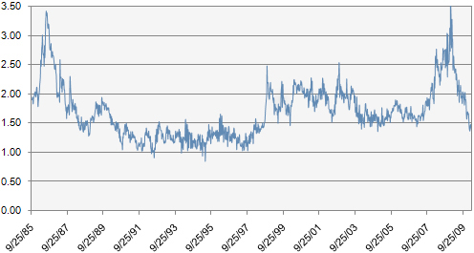

### Credit Cards

Credit-card debt had grown unabated each year over two decades, peaking at $989 billion at the end of 2008. HM: What were they spending it on? Can we get the annual segment breakdowns from the major card companies? As the recession and the financial crisis accelerated in the fall of 2008, the credit card securitization market collapsed from nearly $100 billion per year to only $6.3 billion in the six months after October 2008. As homeowners’ finances grew shaky, banks quickly tightened lending standards, reduced lines of BG existing credit on credit cards, and increased fees and interest rates. [Add Federal Reserve consumer data from G.19 series.]

The Federal Reserve’s Senior Loan Officer Survey shows that in the third quarter of 2008, 67% of banks, on net, tightened standards on credit cards relative to the preceding quarter. In the fourth quarter, 59% tightened, meaning that many banks tightened again. In fact, a significant number of banks tightened credit card standards quarter after quarter until the summer of 2009. Only in the latest surveys have even a small number of banks begun to loosen standards. [Will get latest data.]

Total household borrowing began to slow in 2005. [Need to clarify what happened in 2005.] For the four quarters ending in the first quarter of 2009, borrowing actually fell for the first time since the Federal Reserve began collecting data in 1952. And, household debt has fallen in every quarter since the first quarter of 2009. [PA versus earlier reference in section on household wealth re debt remaining static will asset values/ wealth fell] . [BG Is this necessarily a bad thing?]

### Consumer confidence BB [We should stress the causes of the economic crisis: financial market problems caused the economic crisis,, but the crisis then tended to perpetuate itself through decreased consumer spending and confidence, etc.] [WMT: We need to explain why this is an important indicator.][KH: I have the same concern about trying to tell a continuous economic story from late 2006 through 2008, rather than the three stage story I describe in my recommendation on (16) above. Recommendation:  If consumer confidence plummeted in late 2008 (as it appears from the graph on p. 36), say that, rather than trying to describe a continuous decline from late 2006 that does not appear to be reflected in the data.]

With a loss in jobs, wages, and wealth, and with great uncertainty Pa about the future, consumer confidence fell.

Confidence began to PA decline in late 2006 and had dropped more than 40 percent by late 2008, according to the Index of Consumer Sentiment. In November 2008, the index hit its lowest level since 1980. The Conference Board’s consumer confidence index similarly fell by about half from early 2007 to the end of 2008.[21]

[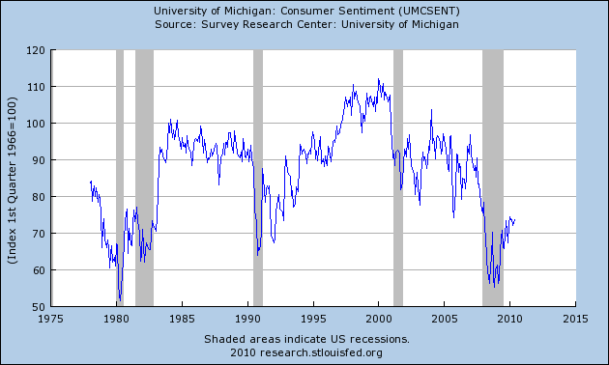](http://research.stlouisfed.org/fred2/graph/?s%5b1%5d%5bid%5d[1][id]=UMCSENT")

### Impacts on consumer spending BB [We need to discuss the importance of consumer spending to the health of the economy and the impacts of the drop in spending.]

By the middle of 2008, the effects of the housing and PA financial crisis caught up with the American consumer. [KH: “By the middle of 2008, the effects of the housing and financing crisis caught up with the American consumer.”  How do we know the causal effect here?  The bracketed comments partially address this. **Recommendation:  Staff should provide support for the claim that housing and financing problems caused the drop in consumption.]** Consumer spending, adjusted for inflation, fell by 3½ percent at an annual rate in the third quarter of 2008 and 3% in the fourth quarter.

These declines are remarkable given that households typically work hard [WMT: What does “work hard” mean? Is this a conscious decision or just is consumption smoothing something that consumers do naturally?] to keep their spending on a steady path. The economy hadn’t seen drops in consumer spending like these since the early 1980s. [TO COME: discussion of how much of these declines can be explained by drop in wealth alone. Discussion will raise points that previous spending behavior shows that wealth declines can’t explain it all. Spending drops were too fast. Confidence played a big role. And, very likely, tightening up in credit markets played a role. Certainly, with better credit markets, more households would take advantage of refinancing which would leave more money every month to potentially increase spending. Need a discussion of the effect of government stimulus on consumer spending.]. DHE **[Over my dead body. You have no way to do any science on this.]**] [WMT: Going to be hard to tease out different effects] .][PA when it comes to items like government stimulus, we need to describe facts of what it is and avoid debate (probably unresolvable re its effects – we have enough to sort thru in evaluating financial crisis and how it became an economic crisis][KH: (1) This is a hotly debated question.  (2) I don’t know of any generally accepted consensus answer.  (3) Please see my earlier comments about whether or not we will discuss policy actions taken to deal with the crisis. **Recommendation:  Drop reference to government fiscal stimulus (or revisit the broader question about whether the report will discuss policy actions taken.)]**

For years, of course, economists have lamented the nation’s low savings rates. Now they agree that savings shot up—and spending declined—too quickly [WMT: What does too quickly mean? This sounds like we are saying that consumers shouldn’t have begun saving as much as they did][KH: I assume there is broad agreement that savings dramatically increased and spending dramatically decreased beginning in late 2008, but “too quickly” is a judgment call and suggests comparison to some “proper” objective standard. **Recommendation: Please back up “too quickly” or change the language to remove the judgment aspect. If there is a standard, and if a range of economists do agree the change in behavior was “too quick,” please provide evidence of this agreement.]** during the crisis, curbing demand and slowing the recovery.

The personal saving rate was close to an all-time low of [1% at the beginning of 2008]. In the latest data, the saving rate was [5%]. [WMT: We need to specifically define personal savings rate, I think. What is “disposable personal income”?] For nearly a quarter-century, consumers powered U.S. and global economic growth as they spent and drew down their savings. . [PA more specifics re proportion of economy pre and post crisis] The American consumer can no longer be counted on to drive the national BG and world economies. .[PA phrasing to tie to where we stand at book publication, not future projection][KH: I like it, but it doesn’t belong here and may not belong in this report.  I don’t know what it has to do with the financial or economic crisis, and it certainly does not belong in an “effects” section of the report.  The last sentence, “The American consumer can no longer be counted on to drive the national economy and the world’s” may be true, but I assume it involves some significant judgment about future patterns of global economic growth.  If we’re going to say that I’d like to be convinced that we have a very high degree of confidence that it’s true. **Recommendation:  Strike the last paragraph on page 37.  If it is relevant to a cause of the crisis, move it there.]**

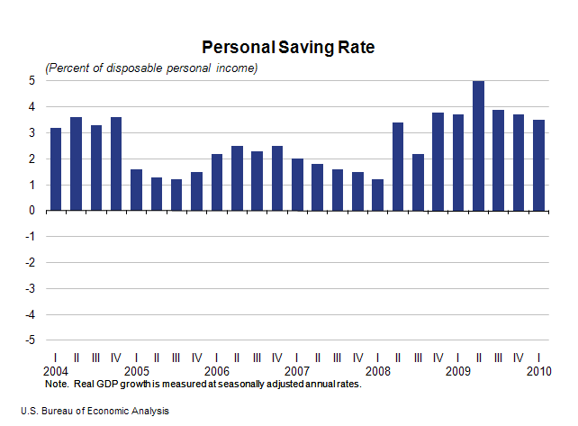

In recessions, consumers typically postpone purchases of big durables. A household can eke out one more year from that clunker of a car while waiting for the economy to improve. HM: Maybe, maybe not. High rate auto loans are often to people whose car means the difference between a paycheck or no paycheck. There is much predation in auto loans As a result, auto sales often fall during recessions. In this recession, disruptions in credit markets also led to increases in rates to finance vehicle loans, which made the financing of auto purchases more expensive.[22] The problems in asset-backed securities markets in 2008 led to higher interest rates on car loans, as shown in the chart below. While the federal term asset-backed securities loan facility, or TALF, helped to bring financing rates back down in 2009, survey evidence suggests that banks continued to tighten auto-loan standards through 2009. [Will cite survey evidence.] [WMT: I know that autos are a nice indicator here, but there are so many complicating factors: (1) wealth impact; (2) credit impact and (3) government support. Are there other durables that we could use that are more easily explained?]

Auto sales peaked in May 2007 and then declined for 26 straight months. By July 2009, monthly auto sales had declined [40 percent] from the pre-crisis peak in 2007. The spike in sales in 2009 BG was caused bythe federal CAR Allowance Rebate System, or “Cash for Clunkers” program. Before the program, 9.67 million vehicles sold in the US in June of 2009; with the program in full swing in August, 14.07 million sold. [BG: I question these numbers. Are these annualized rates???]

The CARS program, which ran through the end of August, provided a rebate of $3,500 to $4,500 per car for customers who traded in an older vehicle to lease or purchase a new and more fuel-efficient one. The program received applications for nearly 700,000 trade-ins worth $2.8 billion in rebates. The domestic auto industry also got a boost of $[XX] billion in TARP money for the Big Three automakers. [PA not Ford, right?] Overall, as auto sales have still remained depressed, about 300,000 jobs have been lost in the auto sector since the beginning of 2008. [KH: Again the “continuous decline from [May 2007] through mid 2009” meme is misleading.  The graph on page 40 shows only slight declines through the end of 2008, followed by a steady decline through the first two-thirds of 2008, followed by a severe drop in late 2008 and early 2009. **Recommendation:  Modify the first two sentences to reflect these three stages of auto sales, consistent with my earlier comments.][**KH: See my earlier comments about whether we’re going to discuss policy actions taken.  If we are, then we should somewhere label CARS by its more popular name, “Cash for Clunkers.”  In addition, this paragraph seems to be trying to imply that CARS helped the auto sector without explicitly stating that.  I would guess that CARS was primarily a timing shift as one would expect, for instance from a temporary sales tax holiday.  We should either say “We think CARS helped the auto sector,” or “We think CARS didn’t help the auto sector that much.”  Or, if we don’t know, we should say something like “There is debate about whether CARS worked.  Some argue X, while others argue Y.”  Or we should just strike this paragraph to be consistent with not discussing policy actions taken during the crisis**. Recommendations:  (1) Make a high-level decision about whether the report will discuss policy actions taken.  (2) If we do discuss policy actions, try to reach a conclusion about whether CARS helped the auto sector or just shifted the timing of cars sales.  (3) If this paragraph stays, then add “Cash for Clunkers” somewhere so that people know what CARS is.]**

#### Student Loans BB [Has there been a decline in college enrollment or any other effects of thelimitations of lending?]

[Will include a discussion on disruptions in the student loan market.]

[Households have also cut back on investment in education. Discussion of crisis related issues in credit markets used to finance student loans: Private student loans, Sallie Mae student loans, college savings accounts.] [PA college savings accounts not used to finance loans – impact there was loss of asset value ]

[Since the start of the recession, the crisis has dramatically limited the availability of home-equity loans and private student loans that families commonly use to finance college educations.]

#### Downward spiral makes credit crunch worse

[Real effects then come back to haunt banks: The retail sector suffered broadly because of cutbacks in spending. Retail sector lays people off. Further weakens job market. General Growth Properties’ bankruptcy. General Growth’s failure was the largest bankruptcy of a US real estate company. Other problems in commercial real estate sector. [PA commercial real estate warrants more than a passing mention. Very significant issues, significant amount of debt coming due, significant amount of assets on balance sheet of fin institutions.] These bankruptcies/defaults lead to bank failures. Will chart bank failures. .[PA this really belongs in financial sector section although you can refer to impacts to financial institutions here] Further constrains credit.] [KH: The “real economy weakness leading to further bank failures” concept is interesting and new to me.  I assume this refers to real economy weaknesses resulting from the crash in Fall 2008?  The commercial real estate point, as I understand, doesn’t jibe with this idea.  I may be wrong, but I have always understood the commercial real estate problems to be parallel to the residential mortgage problems, and thus they were causes of the financial shock, not effects of the real economy effects of the initial financial shock. **Recommendation:  Please provide evidence to support the argument:  financial crisis à weakness in real economy à further bank failures.  Please clarify whether commercial real estate problems were a parallel cause of the initial shock, or an effect at the end of this proposed chain.]**

### Retirement Accounts and Pension Funds

[This section will discuss huge losses in private defined benefit plans.]

[Discussion of losses in defined benefit plans: Defined benefit plans lost $700 million, [PA/BG I am sure billion] or some 40%. BB [This seems to be a negligible amount compared to other retirement fund losses.] This discussion will include what they were invested in. Private pension plans also lost more than one-third of their values, falling from $4.3 trillion to $2.8 trillion.] BB The discussion on public retirement plans that appears below should be consolidated with this discussion.] [BG: This section requires significant research. I suggest a front page New York Times article that appeared on a Sunday about 2 to 3 months ago that details the losses of major pension funds and the resultant rise in underfunded status of such funds and the structural difficulties in recovering over time from severely underfunded status. This section should also include a discussion of the long term consequences to the economy of the underfunded status of pension funds including reduced future retirement benefits for current and future retirees which, when combined with increased longevity will result in dramatically reduced resources for retirees, leading to reduced spending which will dampen economic activity and increased needs putting further pressure on senior safety net protections, including Social Security and Medicare, at a time when federal, state and local governmental entities are impacted by lower revenues resulting from reduced economic activity.] HM: real examples of changes in retiree behaviors [PA we need clarity re this section. Since you refer to public pension funds under government spending (which makes sense since they are defined benefit plans with the cost implications for taxpayers), it seems like what you mean to address here are other defined benefit plans such as corporate plans and Taft Hartley plans. I assume that 401ks, defined contribution plans are covered in the household wealth section. Don’t believe the right terminology here is ‘private pension plans”.

## Impacts on government spending

[Intro will show how the downward spiral in income taxes, capital gains taxes, and property taxes, combining with the credit crunch, all lead to problems for state and local municipalities, which all then cut back on benefits and raise taxes.] BB [We need to discuss in much greater detail the impact of reduction in state and local spending including unemployment, lack of services, impairment of safety net, reduction in production, etc., and how it may be contributing to the economic crisis.][KH: It’s important in this section that we distinguish between the effects of the financial shock and ensuing severe recession on state finances, from the unrelated financial problems of certain states caused by their inability to govern themselves (e.g., California).  While the financial crisis undoubtedly worsened the California budget situation, those are far from the only problems in California’s budget. **Recommendation:  Be careful throughout this part to explicitly flag that (1) States are in different positions based on their particular pre-crisis fiscal policies; (2) the state fiscal effects of the crisis were a significant contributing factor to weak State budget pictures, but in some (many?) States were not the only reason for a budget crisis; and (3) the housing price shocks hurt States differently.  Be particularly careful about using states with significant pre-crisis budget problems (like California) as examples of the effects of the crisis.]**

### State and local government finances

[Disruptions in state and local borrowing] [PA yes they existed, but I think heart of state issues is what has happened to revenues and to expenditures and caseload demands. Also, some(many?) states- e.g CA, came into crisis ill prepared – in the case of CA, expenditures routinely exceeded revenues in the “good times”)

The financial and economic crises have devastated state and local finances, despite the massive financial aid provided by the stimulus. For states, according to Mark Zandi of Economy.com, “Tax revenues are off an astounding 9% for fiscal 2010, by far the largest decline since just after World War II. Personal income, capital gains, sales, corporate income and property tax revenues are all off sharply.”[23] [Will cite primary sources for this data.]

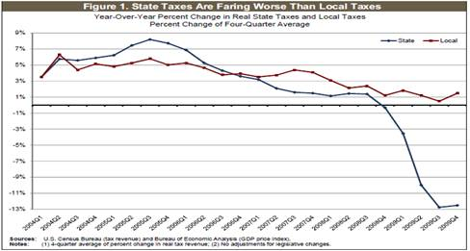

Unlike the federal government, almost every state has some form of a balanced budget requirement, meaning that deficits are not an option; austerity is the only choice. States have closed $300 billion in budget gaps since FY2008 through spending cuts and tax increases, which couldn’t have come at a worse time for the economy. States will likely need to cut spending or raise taxes by another $125 billion in the coming two to three years.[24] [PA will have to update this data in this paragraph because most states have just or are now adopting their 2010-2011 budgets] [ Also should be real examples of impacts – both revenues and program cuts]

State and local revenues have dropped much more dramatically in the economic crisis than during the recession earlier in the decade, as the below chart illustrates.



Figure

To compound matters, the cost of borrowing has grown. [Add more on credit market problems] Still, even at these higher costs, governments continue to borrow: The debt of state and local governments has more than doubled in this recession, from $[XXX] billion in [20XX] to $[XXX] billion in [20XX].[25] [PA this doubling number seems odd to me – their long term debt?]

Some states were hurt more than others. New Jersey Governor Chris Christie is proposing chopping off $11 billion – 25% of the state budget this year – to eliminate the budget deficit. BG Nevada, already one of or the lowest or the lowest state in the nation in per capita state revenues, has seen state revenues drop dramatically and in calendar 2011, when the biennial legislature meets again, will face further revenue losses of XX% from the already low levels of 2009 and 2010. California, where tax revenues are particularly dependent on capital gains and income taxes, was hit hard by declines in wages [PA phrasing – it’s unemployment more than wages per se, right?] and stock prices. California is reducing spending from $103 billion in FY2007-08 to $83 billion this year. [Need to cite most recent statistics.] Everything from state universities to highway patrol to environmental programs is under the axe.[26] In California, 37 percent of spending is unfunded. .[PAdon’t know what this means – budget gap isn’t that big currently – but cumulatively, there’s been a big ratcheting back. Best source of info – Legislative Analyst’s Office] [Need to clarify what was cut, what taxes were raised.]

BB [The following discussion should be consolidated with the earlier discussion of retirement funds.] [Discussion of losses in public retirement plans.]

[State and local retirement funds lost 40% of their values, falling from $2.2 trillion to $1.3 trillion.][KH: In the discussion of S&L public employee retirement funds, we need to be careful not to conflate (1) poor investment management by the fund managers; (2) regional differences in housing and mortgage markets; and (3) non-crisis related public pension problems.  These funds were undoubtedly harmed by the financial and economic crisis, but some were harmed more than others, and many of them are chronically underfunded while others are poorly managed.  Let’s ascribe cause and effect carefully here, please. **Recommendation:  On page 44, be more precise about the effects of the crisis on public employee pension funds.  Do not just cite examples of funds that lost money.  Provide evidence of funds that (were better managed and therefore) did not lose dramatically in the market crash.  Explicitly flag unrelated pre-crisis underfunding problems as another important contributing factor to plan underfunding.]**

[For example, the Oregon Public Employee Retirement Fund lost $29 million on mortgage-backed securities and is currently suing the originator, Countrywide.[27] For its part, the San Diego County Employees Retirement Association lost fully a quarter of its value in the economic crisis.[28] The Illinois State Teachers Retirement System, with a complex portfolio including extensive use of over-the-counter derivatives meant to hedge against loss, saw 22 percent of its value in Fiscal Year 2009.[29]]

[Ten years ago, 25 states had fully funded pension plans; as of 2008, only four plans were fully funded; in mid-2010, [XXX] plans were fully funded.[30]]

HM: We need examples of what this means to people - for example – we had to close down our Country Hospitals’ dialysis unit, cancer treatment center and several pediatric units. These people are now just totally out of luck. It was a heartwrenching community discussion.

### Federal Fiscal Crisis BB [I strongly disagree that there is a “federal fiscal crisis” and believe that this subsection should be eliminated. If we have a section on federal spending, we should stress that the federal government has had to become the lender of last resort and that it is engaging in spending to support the economy and prevent a depression..] [PA make title non- pejorative – we need to describe the facts . Also, seems to me there are two impacts (maybe more) we should discuss: what the federal government did to support financial system and economy and what impact the economic crisis had on government finances]

The federal government was also hit hard by lower tax revenues and the extraordinary outlays associated with the crisis. Notes Zandi: “The budget deficit ballooned to near $1.4 trillion in fiscal 2009, up from $475 billion in fiscal 2008. This year’s deficit is expected to be a similar $1.4 trillion; the cumulative deficit over the fiscal 2009–2012 period is expected to total some $4 trillion.” Zandi expects the final taxpayer cost of the financial and economic crises to be more than $2 trillion, or 14% of GDP. [PA need detail/refinement/most up to date info prior to publication. Also discussion re impact of committing capital for this purpose – direct impact of financial crisis on larger economy/federal fiscal position][ [Will cite source other than Zandi.]

According to Zandi, the weaker economy, with its loss of tax revenues and increased transfer payments for unemployment and income support, will cost the Treasury an estimated $800 billion.[31] [PA again, update as of publication] [Will cite cost of other financial crises PA including S and Ls].] [KH: Citing Zandi for budget and tax numbers?!? **Recommendation:  Cite OMB/Treasury/CBO/Joint Tax for outlay and revenue numbers.]**

### The Financial Sector BB {Why is this discussion of the profitability of the largest banks in a subsection on government spending? Is it because government support is the reason for their profitability? I would either eliminate this subsection or place it elsewhere and use it to compare with the situation of the commercial sector. If we include it, we should list the number of bank failures and troubled institutions and the government expenditures to support the banking sector. We should also t mention the concentration of profits from trading by the big banks.][KH: This is odd.  The draft cites particular examples of those who lost/failed in all other sectors, but this section begins by citing the opposite:  “Many large financial institutions emerged in far better shape than other businesses from the depths of the crash.”  Do we believe that the financial sector as a whole weathered the crisis better than the non-financial sector?  If so, let’s say that.  If not, let’s not pick winners in one sector and losers in another. Shouldn’t we also include the losses/failures in the financial sector from March 2008 through mid-2009, in addition to the big bank profits that began in Q1-ish of 2009? In general, this (rather short) section seems to be trying to paint a picture of “everyone else got shafted, but the big bankers made out great while their employees were laid off.”  If this is true we need to provide a much more robust demonstration of this than the data provided here.  Also, did the whole financial sector do well beginning in early 2009, or just large banks?  If the latter, was it just c-banks, or broker-dealers as well?  What about other types of large financial institutions?  (e.g., big hedge funds, insurers). And if this characterization is accurate, we need a more thorough explanation of why this happened. Recommendation:  The Financial Sector part needs a lot more precision and refinement, especially if we are to make the argument implied by this draft.]

Many large financial institutions emerged in far better shape than other businesses from the depths of the crash. BB [I am not sure that this statement is warranted. Some large bank holding companies are making money from trading activities. They have received and are receiving significant government support and benefits and are focusing on proprietary trading rather than customer services for their profits. Other financial institutions have failed or are still in danger of failure.]Total financial sector profits peaked at $428 billion in 2006.[32] Profits fell in 2007 and 2008, reaching a low of $122 billion on an annual basis in the fourth quarter of 2008, the lowest level since the early 1990s. [Will cite 2009 and 2010 data.] Financial sector profits have returned to the BG 2006 peak [PA precision needed],, boosted by low interest rates and BG access to low percentage government BG borrowing . [Need to break this down among types of financial companies.] [Need to show examples of large institutions.] [PA Yes, major institutions beyond the narrow set of commercial banks set out below] [PA one source of data; NY State Comptroller’s Office puts out regular info re fin sector profits, employment, etc]

Within the financial sector, commercial bank profits doubled from $7.7 billion in the first quarter of 2009 to $15.8 billion in the first quarter of 2010.[33] This rise was mostly experienced among the larger banks in this group.[34] For banks with assets greater than $1 billion, profits more than doubled from $6.6 billion to $14.5 billion from the first quarter of 2009 to the first quarter of 2010. For commercial banks with less than $1 billion in assets, profits rose only 16% from $1.1 billion to $1.3 billion. [PA I believe that the more important dichotomy is between the mega financial institutions and the regional/sub-mega entities, rather than the plus or minus $1 billion. Fine to keep in, but should get data on the really bigs vs others] The number of small banks on the FDIC’s list of troubled institutions continues to rise. [PA #s]

[PA We should deal with failures in this section]

Still, the financial industry has cut jobs. [Again, we will break this down by financial sector and discuss the role of mergers.]  After growing steadily for years, employment in the financial sector fell by 106,000 in 2007, 154,000 in 2008 and another 226,000 in 2009. Areas dependent on the financial industry, such as North Carolina (and in particular Charlotte), have been hit hard. The unemployment rate in Charlotte rose from 4.8% in 2006 to a recent peak of 12.8% in February 2010. Unemployment has fallen modestly since [XXX] BG ], but remains stubbornly high in many areas, like Nevada, with the highest unemployment rate of any state, at 14.2%. [Will add other regional impacts, including New York.]

## Global impacts BB [We don’t have a mandate to look at the global crisis, but it is useful to do so. I think we need to prepare a better evaluation of the spreading of the crisis internationally and the causes of the world-wide nature of the crisis. It might be preferable to include such a discussion in an appendix to the report. One area that is within our mandate is the effect of the international crisis on the U.S. fiancial system and economy: are there any international causes of our distress?][PA General comment re this section – it should be focused on how the crisis transformed from a financial crisis to an economic crisis. It should not be a denovo section re the financial crisis abroad. That should be woven into all the other sections. Also, I think we’re going to have to make a hard decision as a group about how we look at the crisis outside the U.S. – to help explain the U.S. crisis or to fully analyze the extraterritorial crisis][KH: While interesting, this text provides lots of data but little enlightenment.  I have no idea what I’m supposed to conclude. Recommendation:  We need to discuss and understand the purpose of the Global Effects section, then restructure it accordingly.]

[Intro: Other countries had similar financial and economic crises; many were affected by the US crisis directly or indirectly. List of contagion effects would include financial losses, currency pressures, or reductions in global trade.] Just as the US suffered an economic crisis so too did other nations. In 2009, world GDP shrank for the first time since World War II.[35] As the Economic Report of the President 2010 noted:

World GDP is estimated to have fallen roughly 1.1 percent in 2009 from the year before. The number for the annual average masks the shocking depth of the crisis in the winter of 2008–09, when GDP was contracting at an annual rate over 6 percent. In advanced economies, the crisis was even deeper; the IMF expects GDP to have contracted 3.4 percent in advanced economies for all of 2009. The U.S. economy actually fared better than about half of OECD economies during those quarters. For OECD member countries, GDP fell at an annual rate of 7.2 percent in the fourth quarter of 2008 and 8.4 percent in the first quarter of 2009.[36]

The financial crisis was different in each country. For instance, the commission heard testimony that “housing bubbles formed in countries as diverse as Spain, Australia and the United Kingdom where there were few subprime loans and mortgages originated by centrally regulated banks with no sign of American-style securitization.”[37] [Insert chart showing run-up in housing prices by country]. [Will cite primary sources.] Other countries did not experience their own domestic housing bubbles.

Some countries’ financial institutions invested in complex financial products and suffered, as the U.S. did, when their value declined. Some nations were less exposed to these toxic assets but more susceptible to trade disruptions. Each country had its own experience with housing, banking, and recession and thus felt the crisis uniquely. But suffering of one kind or another was nearly universal. A few examples give a sense of how the economic crisis was felt around the globe.

HM: Should we discuss that our role in this may have shaken our leadership in global finance? China is talking about how our currency should not be the benchmark currency any longer and also that our rating agencies should not be the standard setters? Etc.

**United Kingdom**

The financial and economic crisis in the United Kingdom was similar but not identical to that of the United States. In 2006 and 2007, the UK housing-market bubble began to unwind. House prices fell some 25% in the year following the crisis and remain 15% to 20% off of their peak prices.[38] The financial crisis had been building and was most conspicuous with the failure of mortgage-lender the United Kingdom’s Northern Rock in September 2007. When the financial crisis reached its apex in the fall of 2008, the United Kingdom suffered just like the United States. The British economy contracted at an annualized rate of 7.2% in the fourth quarter of 2008 and by a staggering 10% in the first quarter of 2009, shown in the chart below, a slowdown that was worse than the one in the United States.[39]

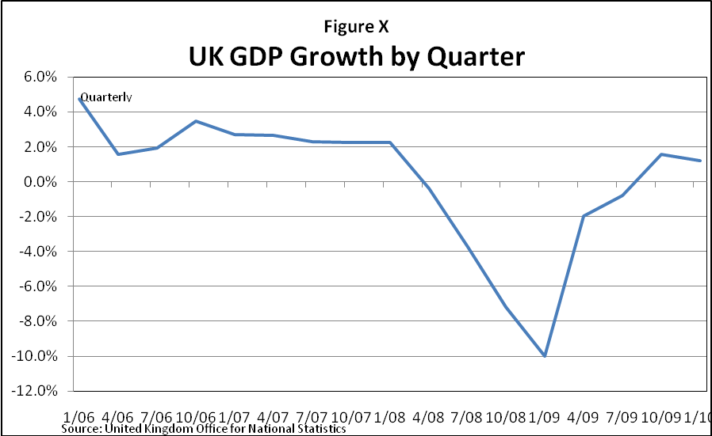

**Eurozone**

Several countries in Europe had housing bubbles burst between 2007 and 2009, including Spain. However, these countries’ banks were more conservative than the UK and US and so made far fewer subprime and interest-only mortgages. Additionally, these countries did not experience recessions until after the financial crisis began in the United States in September 2008.

At the beginning of the financial crisis, European banks had hundreds of billions of dollars of exposure to U.S. mortgage-related assets, and they lost billions. [Note BNP Paribas case study.] Switzerland’s UBS was the first major international bank to announce substantial losses on U.S. mortgage-related assets of $3.4 billion on October 1, 2007; the bank would later announce $37 billion of mortgage-related losses in May 2008.

[Need a chart of all losses by European firms and government bailouts. Other examples include: The Netherlands, Belgium and Luxembourg were forced to bail out bank and insurer Fortis on September 28, 2008. Germany pumped in 50 billion Euros a few weeks later to save German Hypo Real Estate.] The European Central Bank, or ECB, and governments bailed out failing banks across Europe in hopes of preventing an economic crisis.

[Insert transition from financial problems to economic problems.]

[Elaborate on the following points: Credit conditions had tightened; consumer confidence had eroded; global trade had collapsed.] As a result, the Eurozone quickly contracted, at 7.5% in the fourth quarter of 2008 and 9.8% in the first quarter of 2009.[40]

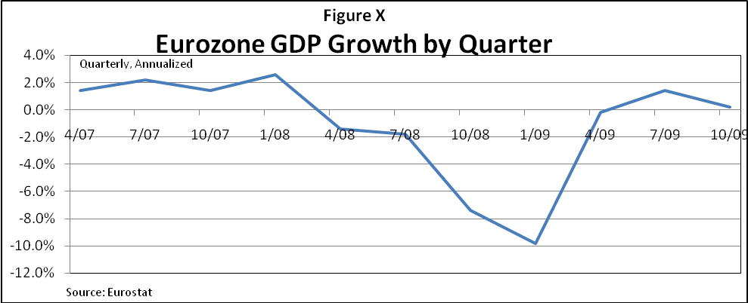

EU unemployment rose from [around] 7.4% at the start of 2008 to 7.8% at the start of the financial crisis in [XXX, 2008]. However, as the financial crisis accelerated, unemployment rose to 10.1% by April 2010. [Will cite current data.]

EU Harmonized Unemployment Rate[41]

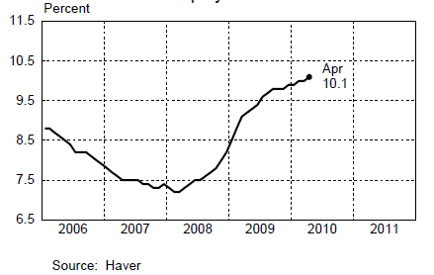

Ireland also experienced a housing meltdown in 2006 and 2007, followed by a banking collapse and a severe recession. Like the US and UK, years of foreign capital inflows gave banks cheap capital that they in turn lent domestically in mortgages. A huge housing bubble ensued (see chart below).

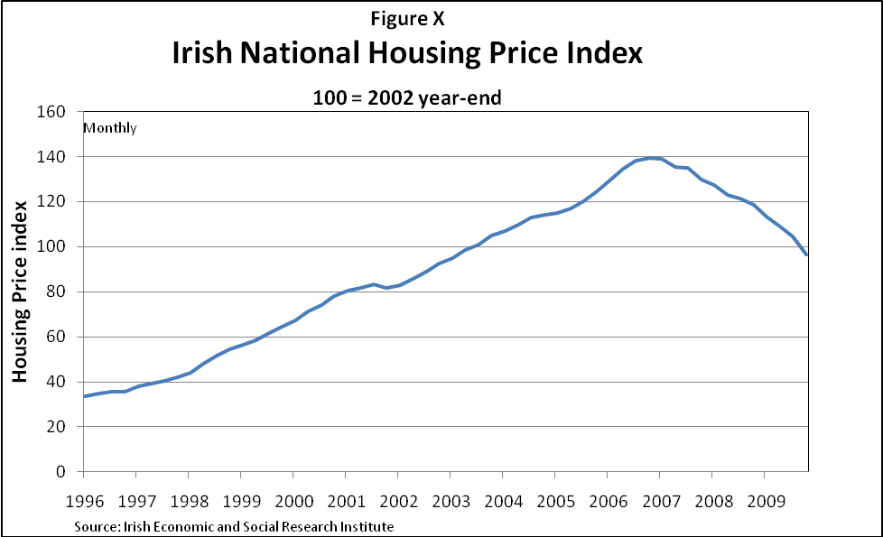

Construction employment rose from 6% of the labor force in 1990 to nearly [13]% in [2006-07].[42] In 2007 the housing market began to weaken. By the fall of 2008, Ireland’s financial sector was reeling. In the most recent data, housing prices remain nearly 40% BG off ???their peak, unemployment stands at 13% and the government deficit is estimated at 11.5% GDP. [Will put in current numbers]. This stands in stark contrast to their government surplus prior to the crisis.[43]

The Irish experience was a bit different from the UK and US in that the country was not officially in recession prior to September, 2008. Additionally, Irish banks did not rely on securitization markets but largely held domestic mortgages on their own books. For the most part, Ireland did not invest in the US mortgage related assets. As the report of the country’s Central Bank suggests, Ireland’s crisis was domestic in nature-- years of borrowing culminating in a crash of its own real estate bubble.[44]

**Other Nations**

[Will be strengthened to systematically discuss each region of the world, and the degree to which contagion of various types was or was not relevant.]

Trade had been a bright spot in the global economy in recent years. However, as the financial crisis peaked in Europe and the United States, exports collapsed in nearly every major trading country. Indeed, world trade fell faster than it did during the Great Depression or at any time since. The level of world trade peaked in May of 2008 and, as the chart below indicates, turned down in September of 2008. While exports have begun to recover they have not returned to pre-crisis levels.

The recession in Japan that began in the second quarter of 2008 quickly deteriorated as demand for exports decreased and companies reduced inventories. Output also collapsed in some emerging-market countries, with some drops in quarterly growth of more than 20 percent at an annual rate in Mexico, Russia and Turkey.

For these countries, rather than a domestic housing bubble or financial crisis, it was interconnectedness to the global economy that brought on the economic crisis. Reliant on trade and foreign demand for growth, countries felt the impact in reduced exports to the United States and Europe.

On the other hand, some emerging countries presented a bright spot. The developing world continued to expand in 2009 at a rate of 1.7 percent. This differs from previous crises, where recessions in the advanced countries were followed by ongoing woes in some emerging countries. [Will get relevant data regarding other countries.]

[BG: I think we need here a section on Asia, China and India, in particular, which differentiates the impact there of the global crisis, as resulting from the decline in export fueled trade, which resulted in turn from the decline of the more mature economies and the ability of their consumers to purchase imports. Of course, the Asian economies suffered a lower percentage drop in their real estate prices except is certain cities which experiences pre-crisis hyper real estate inflation.}

[Need section on international interventions in the Economic Crisis][KH: See my repeated earlier discussions.  We need a decision among the commissioners about whether the report will discuss policy or not. **Recommendation:  Tee up a commission discussion about whether the report will discuss policy.  If it doesn’t, then exclude from this section discussion of the international policy actions.  If we do include international interventions, why do they belong in the “effects” section of the report?]**

[Need section on the role of currency flows]

4811-5449-6774, v. 114837-2344-0390, v. 1

1.
2. Economists have various theories about how the financial system affects the economy. [Discuss.] Fed Chairman Ben Bernanke, in his prior career as an academic economist, had been one of the pioneers in this area of research and was a leading scholar of the Great Depression. In a recent academic paper, three economists argued [PA who?]: “Disentangling the effects of the various channels is difficult if not impossible. But it is also not necessary since all of their outcomes…go in the same direction: downwards.” (Stephen G. Cecchetti 2009). This footnote makes things less clear: We state unequivocally that the financial markets hurt the economy and how, but then seem to backtrack with this note. If there’s a good reason to say opinions differ about the impact of markets on the broad economy, let’s make it very clear here or in the text.
3. San Francisco Federal Reserve Bank, “Is a Recession Imminent?”, November 24, 2006.
4. Economic Report of the President, 2007, page 23
5. The Treasury yield curve compares interest rates for Treasury securities of different maturities. Typically, the yield curve is upward sloping, meaning that it is more expensive for the government to borrow over the long run than the short run. When the yield becomes downward sloping or inverted, it has become more expensive to borrow over the short run. That is seen as a predictor of recessions because it implies that investors are willing to accept a lower long-term return. An inverted Treasury yield curve predicted [XX] of the [XX] recessions between 1970 and 2010; it occurred [XX] times without being followed by a recession.
6. Bernanke, testimony before Senate Banking Committee, February, 14, 2007
7. By the NBER definition, “A recession is a significant decline in economic activity spread across the economy, lasting more than a few months, normally visible in production, employment, real income, and other indicators.”
8. (Economic Report of the President 2010)
9. “As the credit crisis escalated this month, investors were only prepared to buy overnight commercial paper, forcing companies to return to the market for financing each day. Some including Gannett Co. and Southern Co. were forced out of the market. The Fed’s plan is designed to free up cash to entice money market funds to buy more of debt at longer maturities.” (Bloomberg) [Will explain plan.]
10.
11. Interview with FCIC staff.
12. No widely agreed upon definition of what constitutes a small business exists. For example, the Congressional Oversight Panel reports a variety of definitions including [will include]. Hard to define a small business; see COP report for variety and comparison.
13. Small Business Office of Advocacy, 2007-08 Small Business and Micro Business Lending Report, www.sba.gov
14. AbAlert
15. The Consumer and Business Lending Initiative: A Note on Efforts to Address Securitization Markets and Increase Lending,” United States Treasury Department and Federal Reserve, March 3, 2009. http://www.ustreas.gov/press/releases/reports/talf_white_paper.pdf
16. According to Bernanke footnote: “Data are from the Federal Financial Institutions Examination Council (FFIEC) Consolidated Reports of Condition and Income (Call Report), where loans to small businesses, as stated in the reporting forms FFIEC 031 and 041, schedule RC-C, part II, are defined as loans with original amounts of $1 million or less that are secured by nonfarm nonresidential properties or are commercial and industrial loans, plus loans with original balances of $500,000 or less that are secured by farmland or are for agricultural production.”
17. “Restoring the Flow of Credit to Small Business,” Chairman Ben S, Bernanke at the Federal Reserve Meeting Series: “Addressing the Financing Needs of Small Businesses,” Washington, D.C., July 12, 2010.
18. Testimony of C.R.”Rusty” Cloutier to the FCIC, January 13, 2010.
19. Cnnmoney.com: “Small Biz Loan Failure Hits 12%”; February 25, 2009
20. www.equifax.com
21. The Confidence Board, Consumer Confidence Index, <http://www.conference-board.org/data/consumerconfidence.cfm>
22. Board of Governors of the Federal Reserve System, G.19—Consumer Credit.
23. (Zandi 2010)
24. National Conference of State Legislatures, www.ncsl.org
25. Federal Reserve Flow of Funds
26. California Legislative’s Analyst Office, www.lao.ca.gov
27. Oregon Joins Lawsuit Against Mortgage Giant Countrywide, Jeff Manning, The Oregonian, July 14, 2010.
28. Stunned by Losses, Pension Fund Invests with Borrowed Money, Seth Hetenna, voiceof sandiego.org, April 4, 2010.
29. Illinois Pension Fund Uses OTC Derivatives to Recoup Returns, Jeopardizes Pensions, Medill Reports, June 10, 2010.
30. Pew Center on the States
31. (Zandi 2010)
32. Bureau of Economic Analysis.
33. <http://www2.fdic.gov/qbp/2009mar/qbp.pdf>.
34. The Federal Reserve noted: “Profitability diverged between the largest banking institutions and the rest of the industry, primarily reflecting the ability of large banks to generate income from specialized activities in which other banks do not generally participate.” From *Profit and Balance Sheet Developments at U.S. Commercial Banks in 2009*,<http://federalreserve.gov/pubs/bulletin/2010/pdf/bankprofits10.pdf>.
35. International Monetary Fund
36. Economic Report of the President, 2010
37. Christopher Mayer, *Housing, Subprime Mortgages, and Securitization: How Did We Go So Wrong and What Can We Learn So this Doesn’t Happen Again?*, paper presented to the FCIC, February 27, 2010
38. The Guardian, “No real house price recovery likely in next five years”, July 13, 2010
39. ibid
40. Eurostat, 16 Euro Area countries
41. Chart taken from the Global Economic Indicators, Federal Reserve Bank of New York, <http://www.newyorkfed.org/research/global_economy/globalindicators.html>
42. Governor of the Central Bank of Ireland, “The Irish Banking Crisis Regulatory and Financial Stability Policy 2003-2008”, directed to the Ministry for Finance of Ireland
43. Irish Economic and Social Research Institute
44. ibid